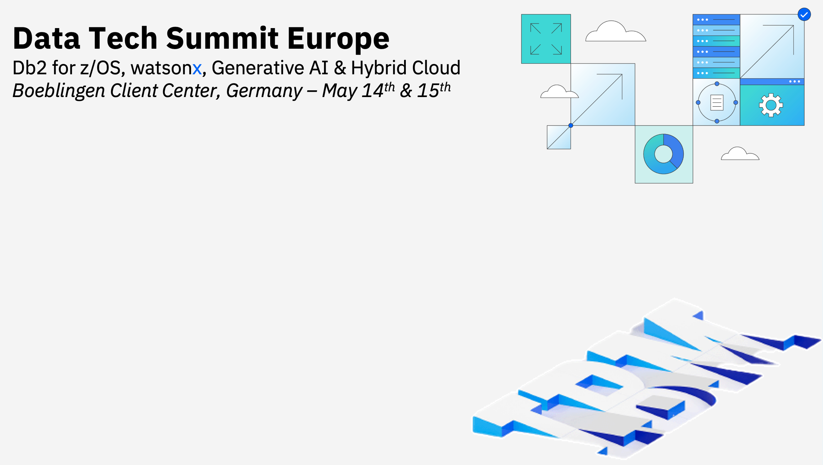

**Db2 for z/OS Data Synchronization with Db2 Data Gate & watsonx.data   
  
  
Guillaume Arnould  
Diego Cardalliaguet  
  
  
October 3rd 1:00-3:10 PM**

**Notices and disclaimers**

© 2022 International Business Machines Corporation. No part of this document may be reproduced or transmitted in any form without written permission from IBM.

**U.S. Government Users Restricted Rights — use, duplication or disclosure restricted by GSA ADP Schedule Contract with IBM.**

This document is current as of the initial date of publication and may be changed by IBM at any time. Not all offerings are available in every country in which IBM operates.

Information in these presentations (including information relating to products that have not yet been announced by IBM) has been reviewed for accuracy as of the date of initial publication and could include unintentional technical or typographical errors. IBM shall have no responsibility to update this information.

**This document is distributed “as is” without any warranty, either express or implied. In no event, shall IBM be liable for any damage arising from the use of this information, including but not limited to, loss of data, business interruption, loss of profit or loss of opportunity.** IBM products and services are warranted per the terms and conditions of the agreements under which they are provided. The performance data and client examples cited are presented for illustrative purposes only. Actual performance results may vary depending on specific configurations and operating conditions.

IBM products are manufactured from new parts or new and used parts.

In some cases, a product may not be new and may have been previously installed. Regardless, our warranty terms apply.”

**Any statements regarding IBM's future direction, intent or product plans are subject to change or withdrawal without notice.**

Performance data contained herein was generally obtained in a controlled, isolated environments. Customer examples are presented as illustrations of how those customers have used IBM products and the results they may have achieved. Actual performance, cost, savings or other results in other operating environments may vary.

References in this document to IBM products, programs, or services does not imply that IBM intends to make such products, programs or services available in all countries in which IBM operates or does business.

Workshops, sessions and associated materials may have been prepared by independent session speakers, and do not necessarily reflect the views of IBM. All materials and discussions are provided for informational purposes only, and are neither intended to, nor shall constitute legal or other guidance or advice to any individual participant or their specific situation.

It is the customer’s responsibility to ensure its own compliance with legal requirements and to obtain advice of competent legal counsel as to the identification and interpretation of any relevant laws and regulatory requirements that may affect the customer’s business and any actions the customer may need to take to comply with such laws. IBM does not provide legal advice or represent or warrant that its services or products will ensure that the customer follows any law.

Questions on the capabilities of non-IBM products should be addressed to the suppliers of those products. IBM does not warrant the quality of any third-party products, or the ability of any such third-party products to interoperate with IBM’s products. **IBM expressly disclaims all warranties, expressed or implied, including but not limited to, the implied warranties of merchantability and fitness for a purpose.**

The provision of the information contained herein is not intended to, and does not, grant any right or license under any IBM patents, copyrights, trademarks or other intellectual property right.

IBM, the IBM logo, and ibm.com are trademarks of International Business Machines Corporation, registered in many jurisdictions worldwide. Other product and service names might be trademarks of IBM or other companies. A current list of IBM trademarks is available on the Web at “Copyright and trademark information” at: [www.ibm.com/legal/copytrade.shtml.](http://www.ibm.com/legal/copytrade.shtml)

**Table of Contents**

1 Lab Overview 5

1.1 Lab Environment 7

2 Exploring the Cloud Pak for Data user interface 8

2.1 Connecting to CP4D 8

2.2 Brief CP4D and Data Gate UI Overview 10

3 Load and synchronize a z/OS Db2 table into a CP4D Db2 LUW with Data Gate 14

4 Learn how applications can exploit synchronized tables. 17

4 Observe “bulk” replication in action 21

4.1 Add the “Demo” table to your Data Gate instance 21

4.2 Load Data into the newly synchronized table 23

4.3 Use the Db2 Console to query CP4D table data (Optional Section) 28

5 Use Db2 for z/OS Data Gate Store Procedures with REXX 32

5.1 Customizing and submitting Data Gate stored procedure jobs 32

6 Using Db2 for z/OS data in watsonx.data with Data Gate 39

6.1 Watsonx.data introduction 39

6.2 Accessing the watsonx.data UI 41

6.3 Watsonx.data Infrastructure Manager 45

6.4 Watsonx.data Data Manager 47

6.5 Watsonx.data Query Workspace 52

6.6 Offloading Data from a Data Warehouse 57

7 Summary 59

# Lab Overview

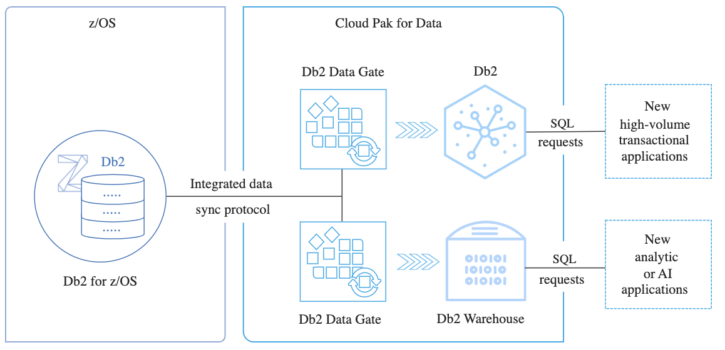

The IBM Db2 for z/OS Data Gate service extracts, loads, and synchronizes your mission-critical data from Db2 for z/OS to Cloud Pak for Data for quick access by your new, high volume, read-only transactional and analytic applications.

Db2 Data Gate leverages IBM Cloud Pak for Data to deliver a synchronized copy of the original Db2 for z/OS data. An application accesses a copy of the Db2 for z/OS data instead of accessing data directly in Db2 for z/OS. The Db2 Data Gate engine manages data on a separate Linux-based system as part of IBM Cloud Pak for Data.

The Db2 Data Gate service uses an integrated data synchronization protocol to ensure that your data is current, consistent, and secure. The fully zIIP-enabled synchronization protocol is lightweight, high throughput, and low latency. It enables near real-time access to your data without degrading the performance of your core transaction engine.

The service propagates your data from a Db2 for z/OS source on IBM Z to a target database on Cloud Pak for Data. You can choose your target database based on your business need. For example, you might set up Db2 as your target database for your new high-intensity transactional workloads, such as mobile banking applications. Or you might set up Db2 Warehouse as your target database for your analytic or AI workloads.

You can configure Db2 Data Gate so that analytical Db2 for z/OS queries are routed to a Db2 Warehouse target database on Cloud Pak for Data. This shifts the query workload and saves valuable z/OS processing resources. In most cases, this will also accelerate your queries. The original encoding of the tables in the Db2 subsystem is retained when you enable the query acceleration feature for your Db2 Data Gate. So, the query results do not differ from the results you get when you execute the query in Db2 for z/OS.

Compared to any custom-built solution, the Db2 Data Gate service reduces the cost and complexity of your application development. By using this service to synchronize and access your enterprise data on Cloud Pak for Data, a cloud-native solution, you can reduce your operational cost while accelerating your journey to the cloud and AI.

In addition to gaining experience with Db2 Data Gate, this lab will also give a hands-on introduction to watsonx.data, IBM’s open data lakehouse. We will demonstrate how Data Gate and watsonx.data can work together to provide real-time access to Db2 for z/OS data in a data lakehouse.

Watsonx.data makes it possible for enterprises to scale analytics and AI with a fit-for-purpose data store, built on an open lakehouse architecture, supported by querying, governance, and open data formats to access and share data. With watsonx.data, you can connect to data in minutes, quickly get trusted insights and reduce your data warehouse costs.

With watsonx.data, you can combine the performance of data warehouses with the flexibility of data lakes, to address the challenges of today’s complex data landscape and scale AI.Optimize workloads from your data warehouse by choosing the right engine, for the right workload, at the right cost and modernize your ineffective data lakes with warehouse-like performance, security and governance. A more detailed introduction to watsonx.data will be provided later in the lab.

During this Hands–on–Lab geared towards Database Administrators, System Administrators, you will get hands–on experience with IBM Db2 Data Gate and watsonx.data. You will learn during this practical workshop the end-to-end technical foundation of Db2 Data Gate:

* Exploring Data Gate user Interface
* Enabling a new table in Data Gate instance
* Loading Data to the new Data Gate table and running Queries
* Integrated Synchronization of Data with Data Gate
* Discover “trickle” and “bulk” replication in action.
* Exploring Db2 in CP4D where data is replicated

After the final section of the lab, you will have gained the following experience with watsonx.data:

* Discover how Db2 Data Gate enables accessing Db2 for z/OS data through watsonx.data
* Understand watsonx.data’s lakehouse architecture
* Learn about key technologies used by watsonx.data such as Presto, Iceberg, Hive, object storage, and database connectors.
* Learn how watsonx.data can help reduce data warehouse costs

## Lab Environment

**Key Products involved in this Hands-On Lab:**

* IBM Db2 for z/OS Data Gate
* IBM Cloud Pak for Data
* Databases:
  + Db2 for z/OS
  + Db2 OLTP
  + Db2 Warehouse
  + PostgreSQL
* Zowe
* watsonx.data

### Data Gate Software

Data Gate Server and cluster software is installed on a z/OS system and an OCP cluster in an IBM lab environment

### Watsonx.data Software

Watsonx.data has been provisioned as a CP4D service, on an x86 OpenShift cluster, in an IBM lab environment. Note that watsonx.data can also be used as SaaS and as a stand-alone install (non-CP4D).

### Student Access

Students will log into their Windows VMs that have been setup in advance with connectivity to the Data Gate environment.

**Lab Instructions:**

Each student should receive a lab worksheet. The worksheet provides information that is specific to each student to use throughout the lab.

Some of the instructions in the lab direct the student to use a variable that is marked with angle brackets (<xxx >). The value the student should use for that variable is on their lab worksheet. Make sure to remove the brackets when replacing the <xxx> variable with the value from the worksheet.

# Exploring the Cloud Pak for Data user interface

## Connecting to CP4D

1. Open the “**Db2 Data Gate for zOS**” folder on the virtual desktop and double-click the “**IBM** **Cloud Pak for Data”** Link. Note: If this is the first time the browser has been opened on your VM, it may take over 10 seconds to start.

Alternatively, enter the **<cp4d_url>** link from your lab worksheet into the Firefox browser which should be on the desktop.

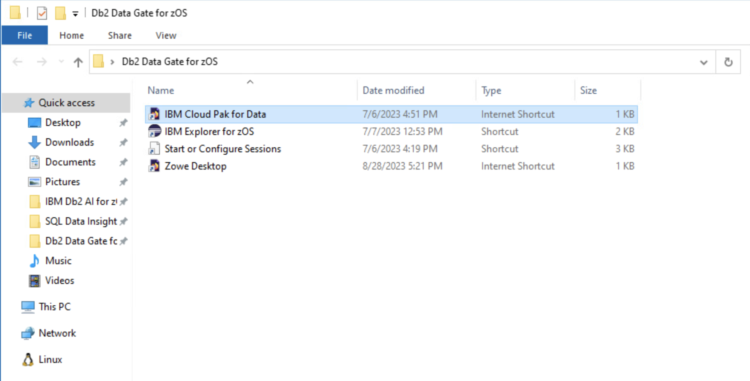

If you receive a security warning, accept the exceptions to proceed to the login screen. For Firefox, click the Advanced button, and then click Accept the Risk and Continue button.

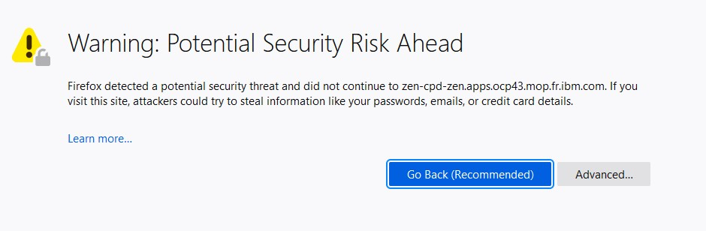

1. The CP4D web client GUI displays as shown. Use <login_userid> and <login_password> as the credentials and click Log in.

Note that the credentials are case sensitive. Also, if you paste the password in, make sure there are no trailing blanks

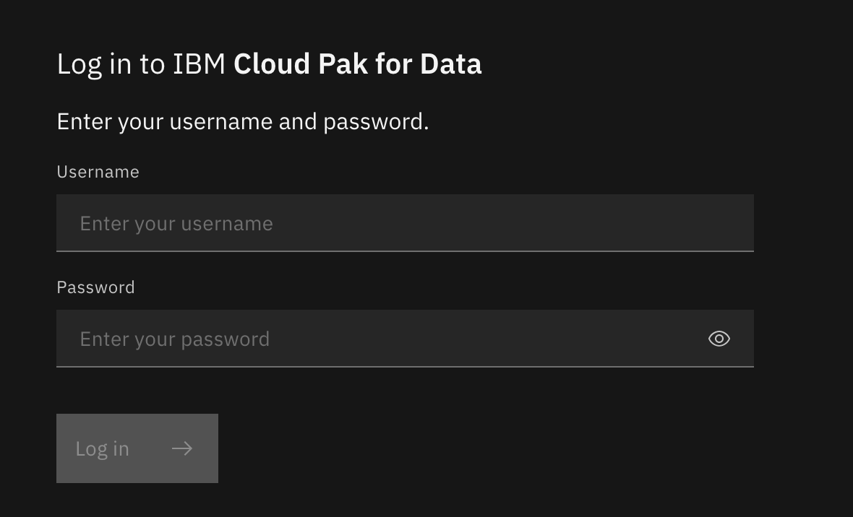

Once logged in, you will see the welcome page of CP4D.

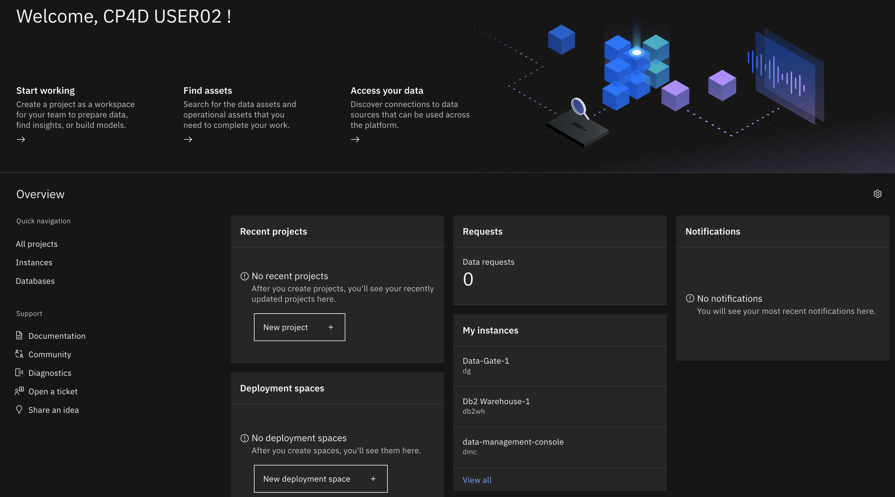

## Brief CP4D and Data Gate UI Overview

1. From the welcome page of CP4D, click on the menu icon (hamburger icon with three horizontal bars) in the top-left corner of the page to expand the Navigation menu. This is the main menu and will be referred to throughout the lab. We are going to explore and explain some of the menu options.

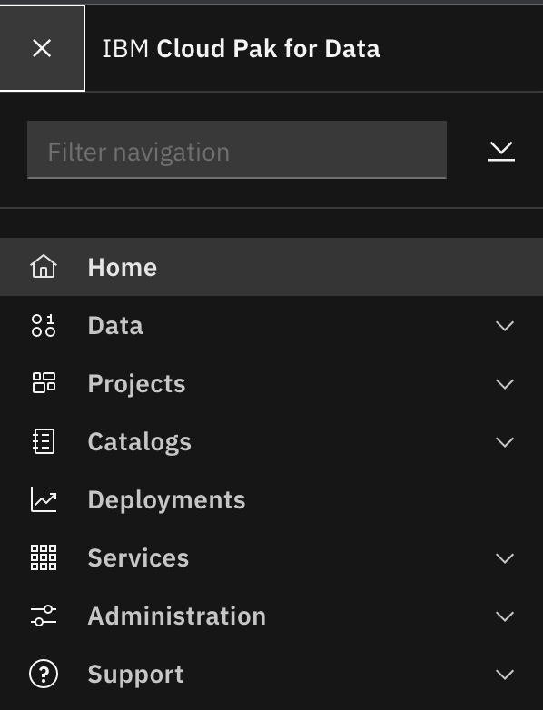

* The “**Data**” section is dedicated to Databases and Data Connections
* The “**Projects**” section is used to create collaborative workspaces where you can prepare data, analyze data, and build models
* The “**Catalogs**” section is used to organize and share resources for many data science projects: data assets, operational assets, and the users who need to use the assets
* The “**Deployments**” section can be used to deploy models and manage your deployments.
* The “**Services**” section is used to manage your services and the associated deployed instances.
* The “**Administration**” section is used to administer your CP4D cluster like managing users, managing the platform and storage volumes.
* The “**Support**” section is dedicated for collecting diagnosis information and provides useful links to documentation and IBM support web site.

1. Expand the “Services” section and Click on “Instances”. If you get an error message, please refresh the page.

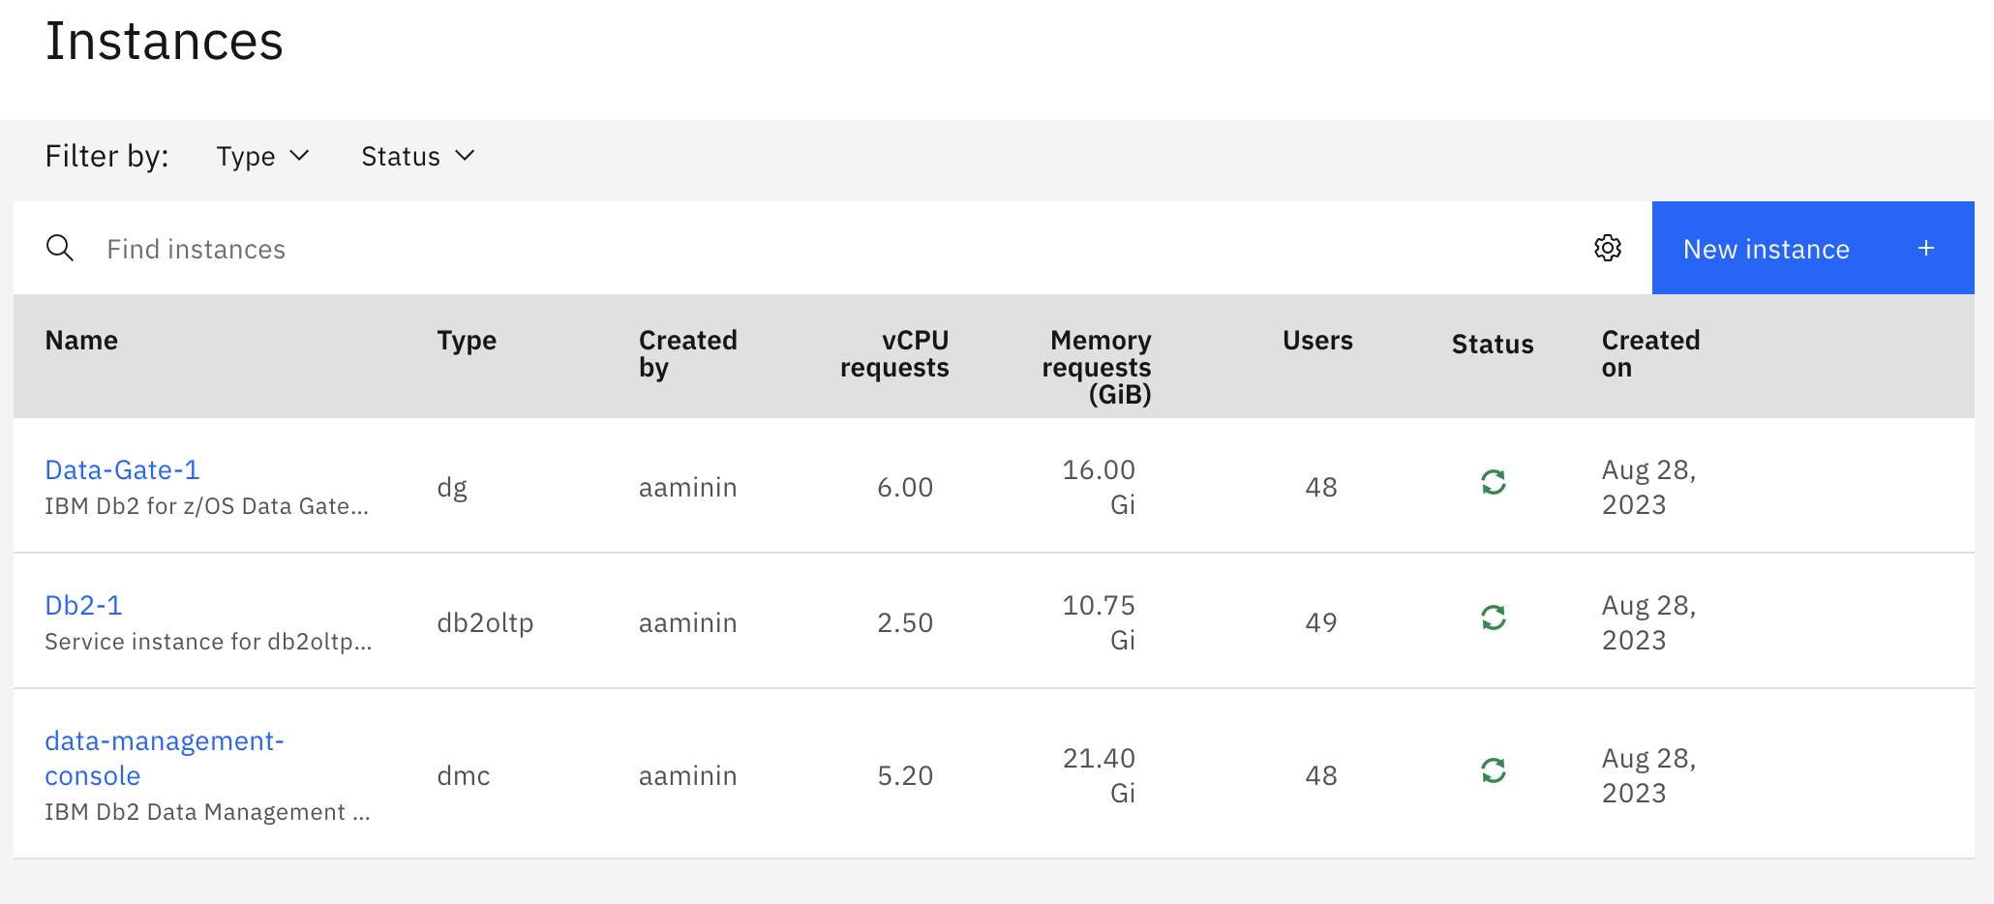

You can see here we have 3 instances of 3 different services deployed:

* 1. The “Data-Gate-1” instance used to manage replication between Db2 z/OS and Db2 LUW in our CP4D cluster.
  2. The “Db2-1” instance is our Linux Db2 (provisioned in the CP4D platform) used to store our replicated data from Db2 z/OS.
  3. The “data-management-console” instance is used to manage our Db2.

1. Click on the “Data-Gate-1” instance to display useful information about the instance. 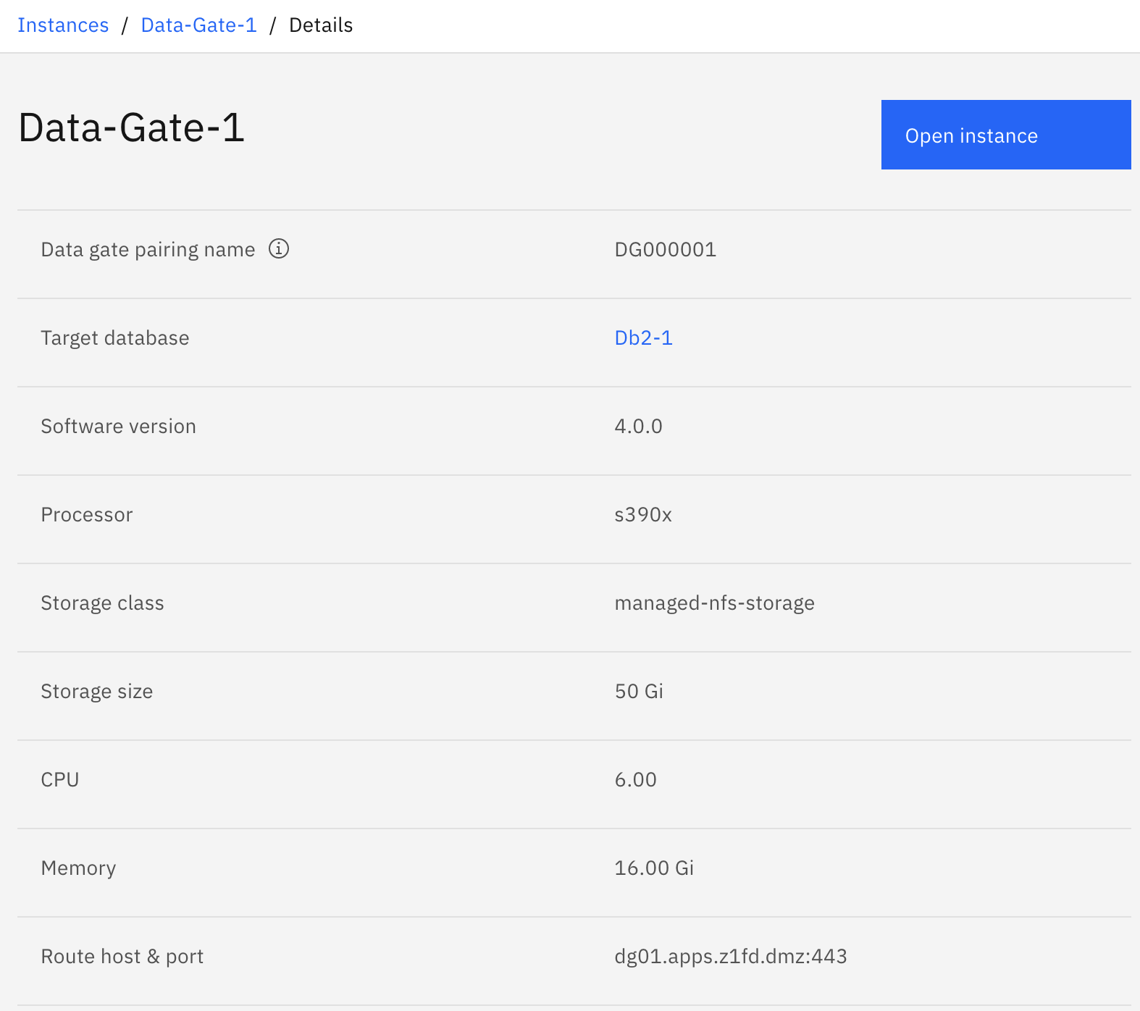

We can confirm here our Data Gate instance is using the “Db2-1” as the target database. We used 50GB of storage on the managed-nfs-storage storage class, and 6 cores with 16GB of memory are configured for the instance to manage synchronization.

The “Route host & port” list is useful as this information is used by Db2 z/OS to communicate with the Data Gate instance.

1. Click on the blue “Open Instance” button to open the UI for the Data Gate instance.

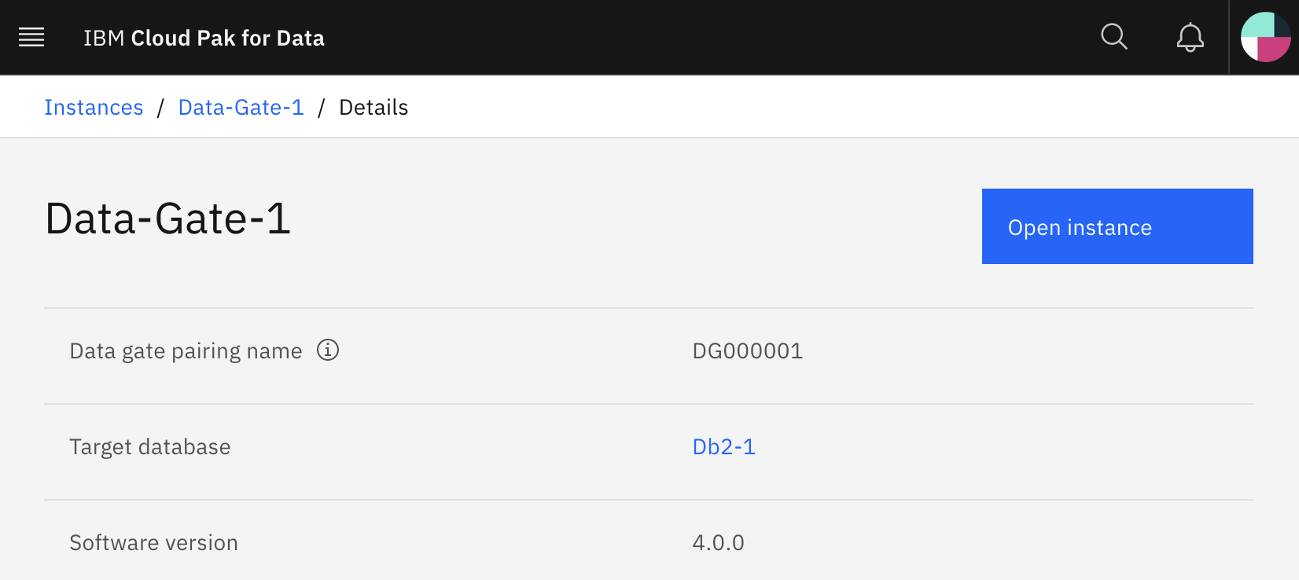

The main Data Gate Overview dashboard appears giving you a snapshot of the Data Gate instance status, Watson Knowledge Catalog integration, and Db2 table synchronization and query status. From here you can see the CP4D target Db2, the z/OS Db2 source, and the data gate server status. Additionally, you can toggle synchronization and publish Db2 table metadata to Watson Knowledge Catalog, a metadata catalog service in CP4D. If a Db2 Warehouse was instead chosen as the target database, then there would be an additional option to toggle query acceleration on/off.

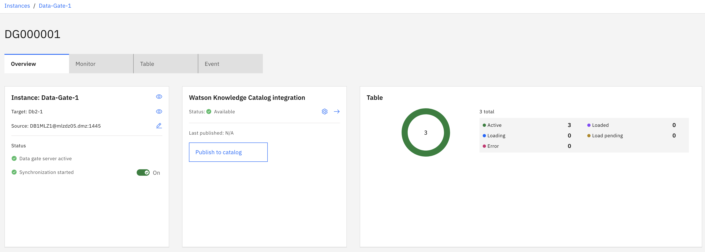

1. Click on the “Monitor” tab. The top two dashboards display information on the Data gate instance performance such as replication latency and throughput. These panels are refreshed automatically, and you can change the time frame shown by the dashboard to see historical metrics from Data Gate.

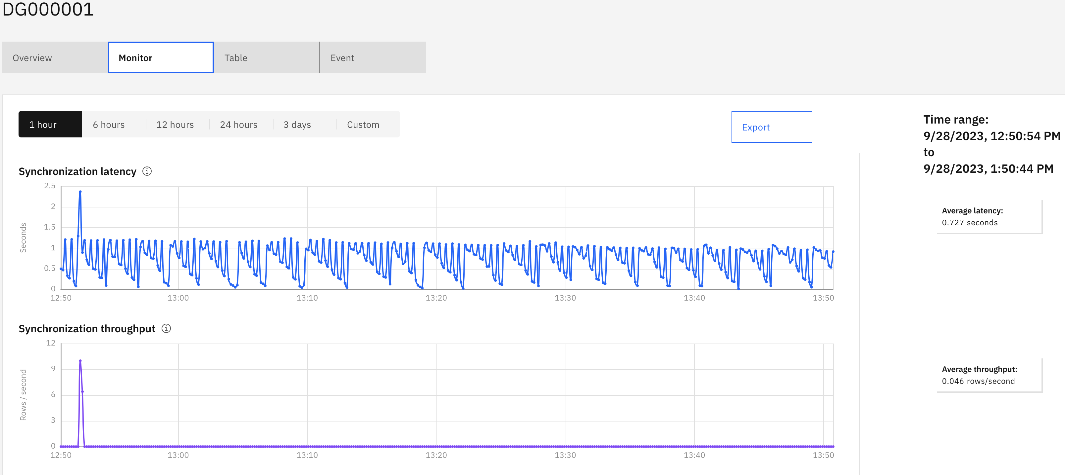

Scrolling down further you can see the “Source data and Target data” graphs which tells you how many operations of a certain type were carried out during the synchronization process, how many compensated rows exist, and how many log records were written by Db2 utilities.

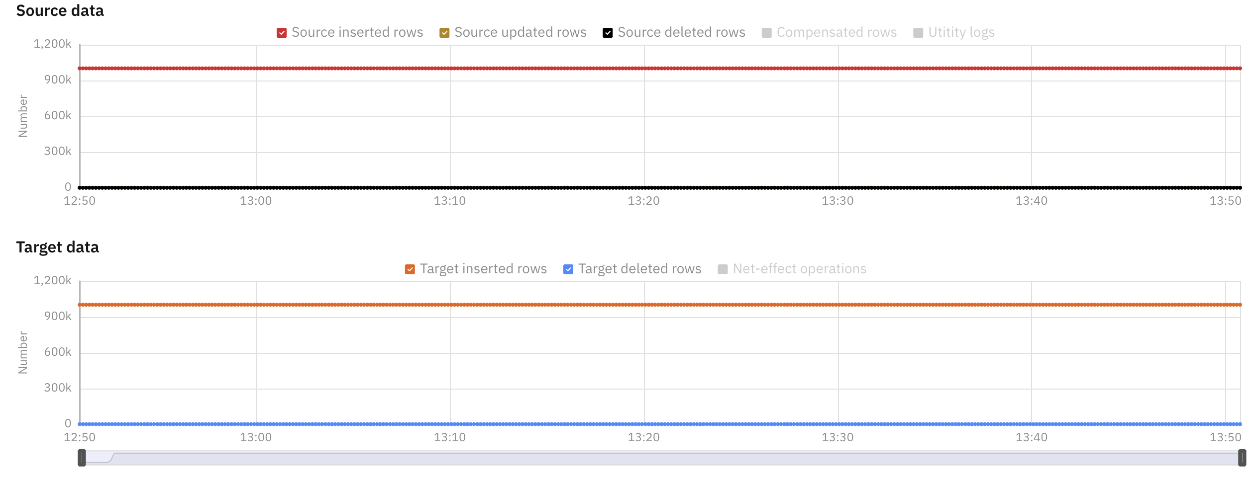

1. Next, click on the “Table” tab. Here you can see details of the current replicated tables in Data Gate. We find here schema and table names along with size used by these tables in Db2 LUW.

Additionally, the status of the tables is displayed: Whether the tables are active, if acceleration is enabled, and if replication is enabled. The Sync started column indicates when synchronization was started for the table.

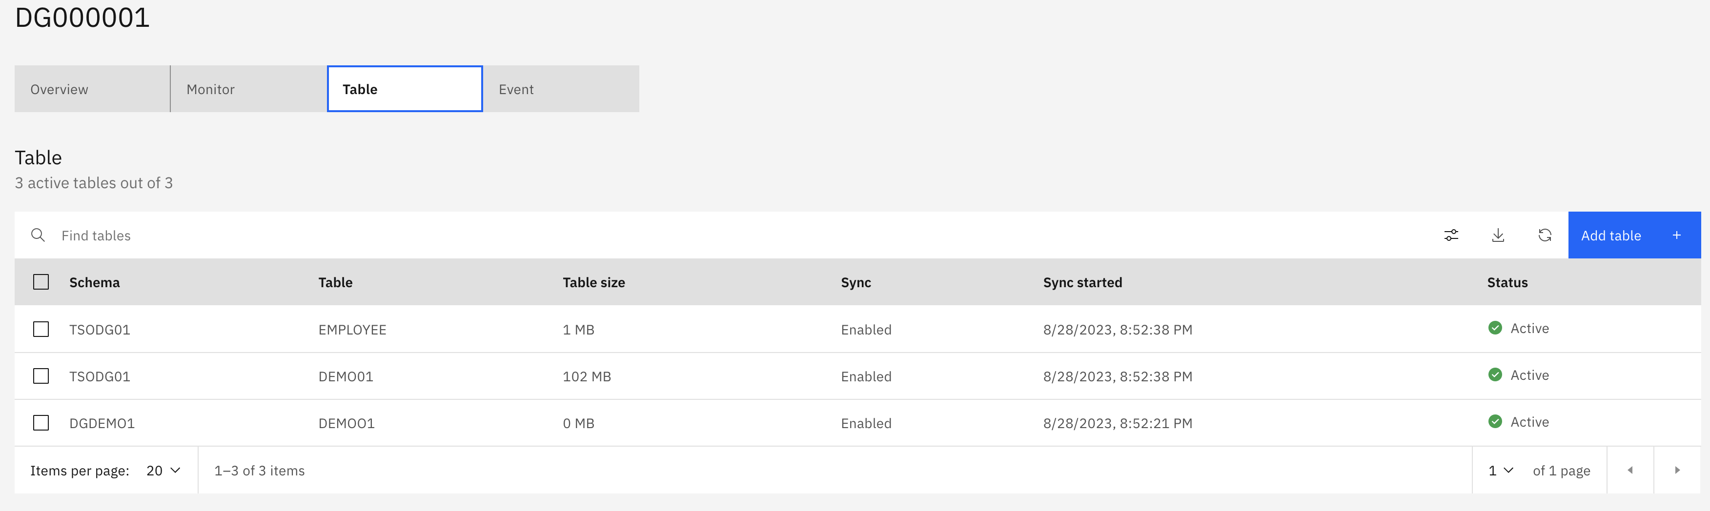

# Load and synchronize a z/OS Db2 table into a CP4D Db2 LUW with Data Gate

This section steps you through the process of adding a z/OS Db2 table to Data Gate so that your z/OS data can be used by new business applications with minimal impact to z/OS Db2.

1. Click on the Add table button at top right of the Tables section

The Add table dialog will appear, showing a list of schemas and the number of tables under each schema.

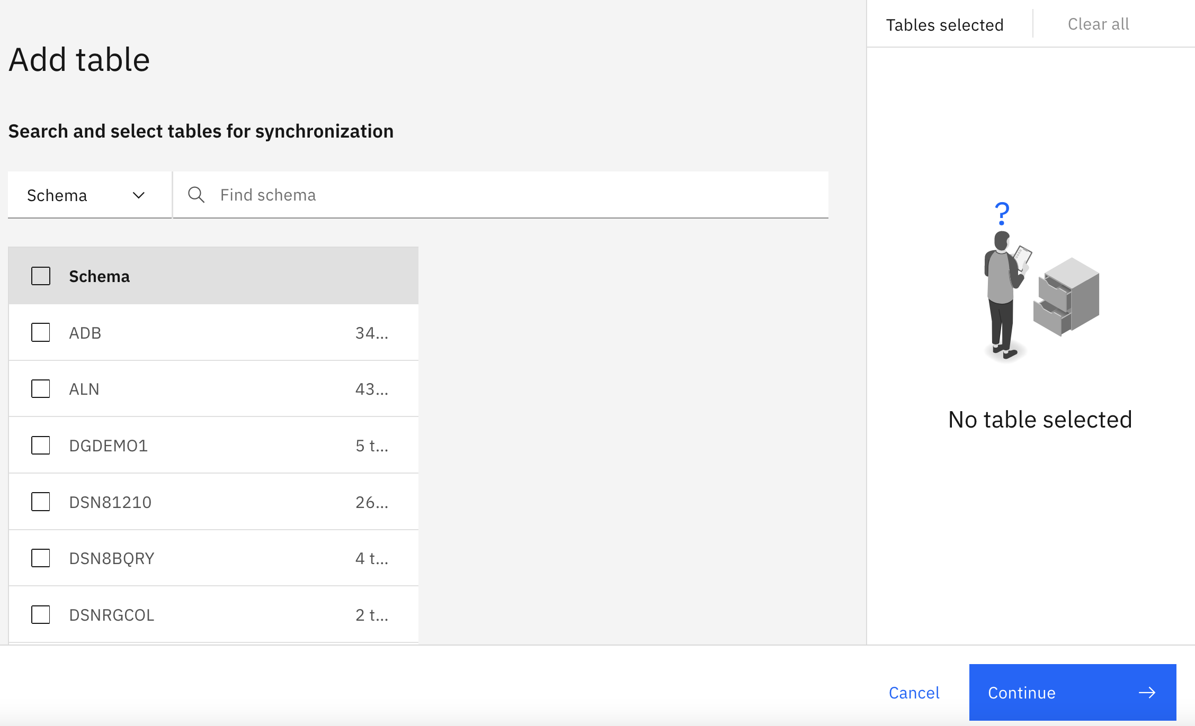

1. Add your user ID’s Employee table.

* Enter <schema> into the Schema search and hit enter (1)
* Select your schema from the schema list on the bottom left (2)
* Check the EMPLOYEE table from the list that appears in the middle (3)
* Ensure that EMPLOYEE is the only table that is selected in the list on the right (4)
* Click the Continue button at the bottom-right

**Note**: If your EMPLOYEE table does not show in the list of available tables to add, it is likely that it has already be added to Data Gate’s set of synchronized tables.

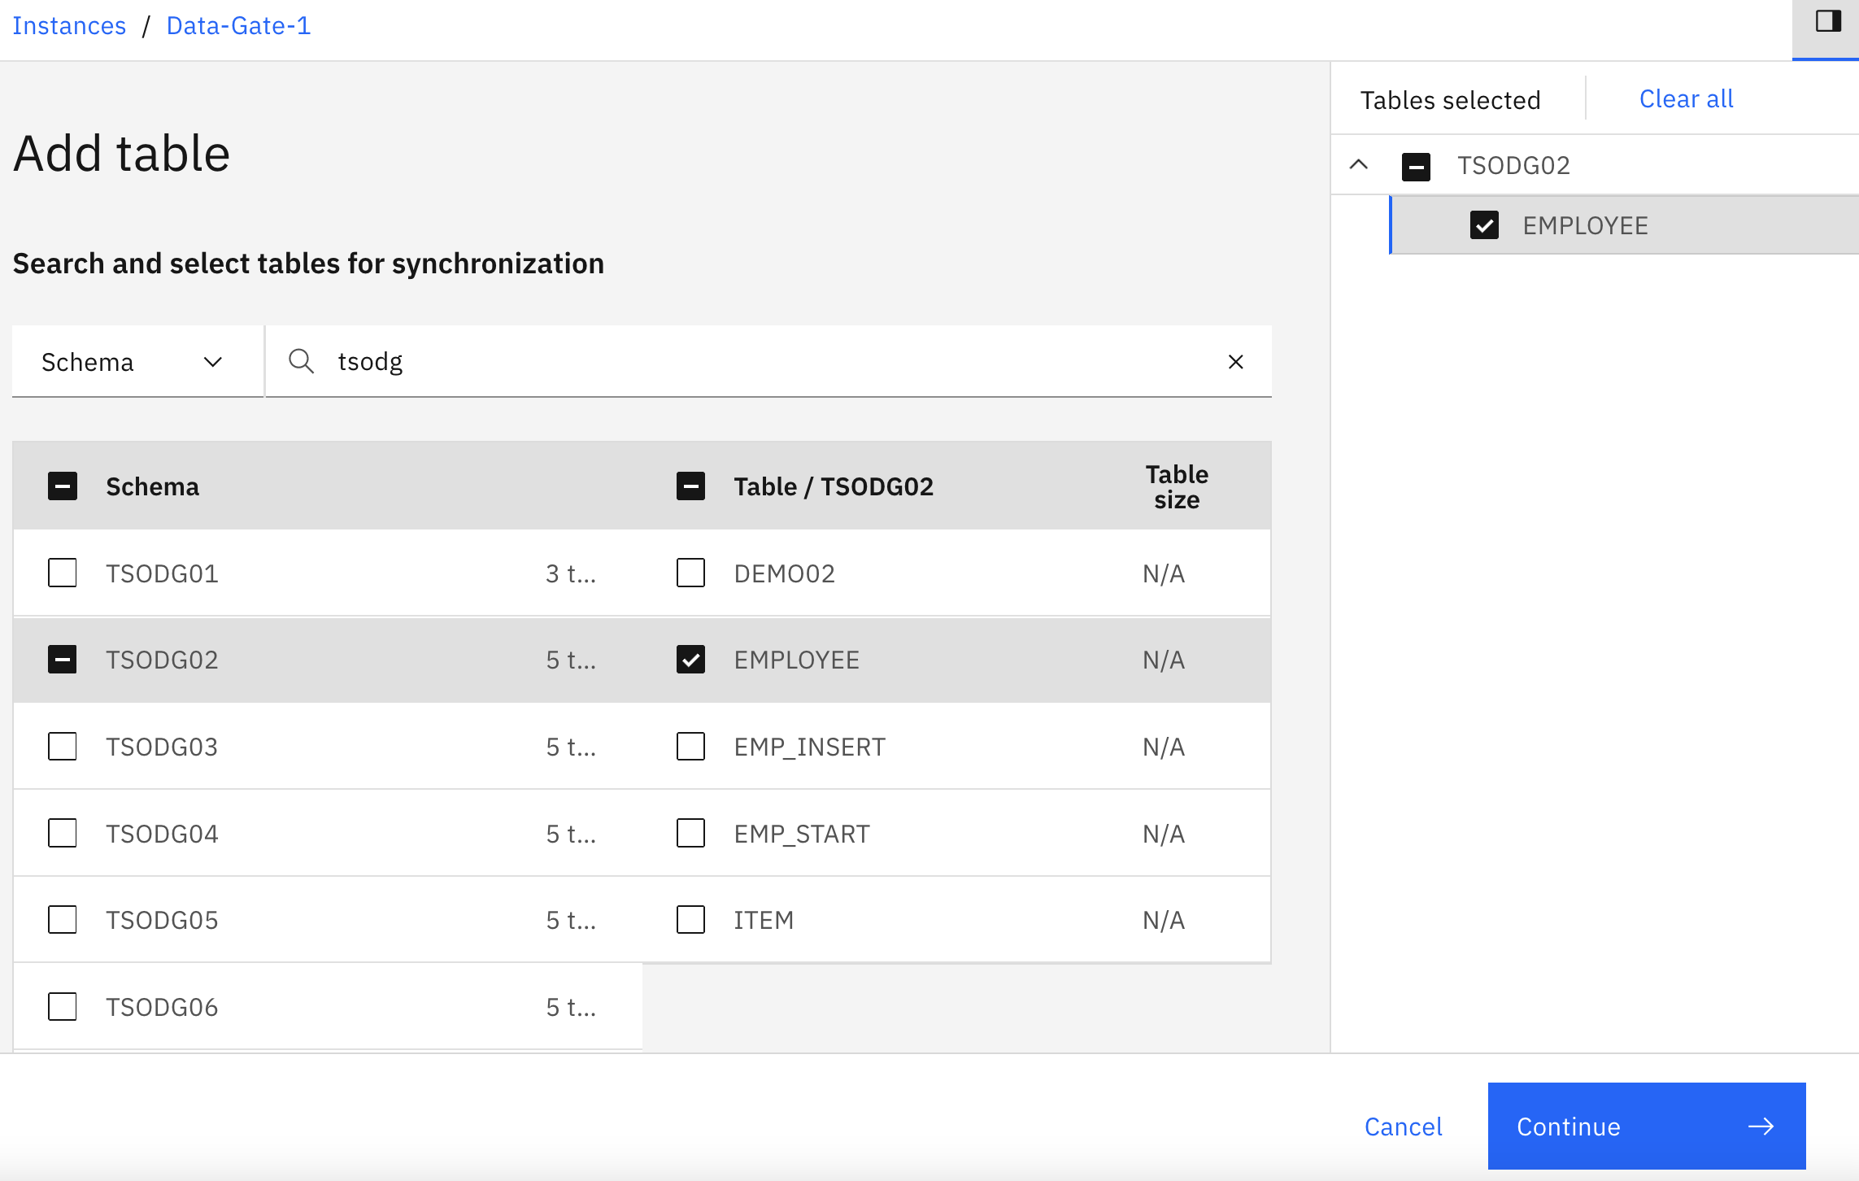

2

4

3

1

1. The add table confirmation is displayed. Ensure that Enable synchronization and load tables is selected, and then click the Finish button

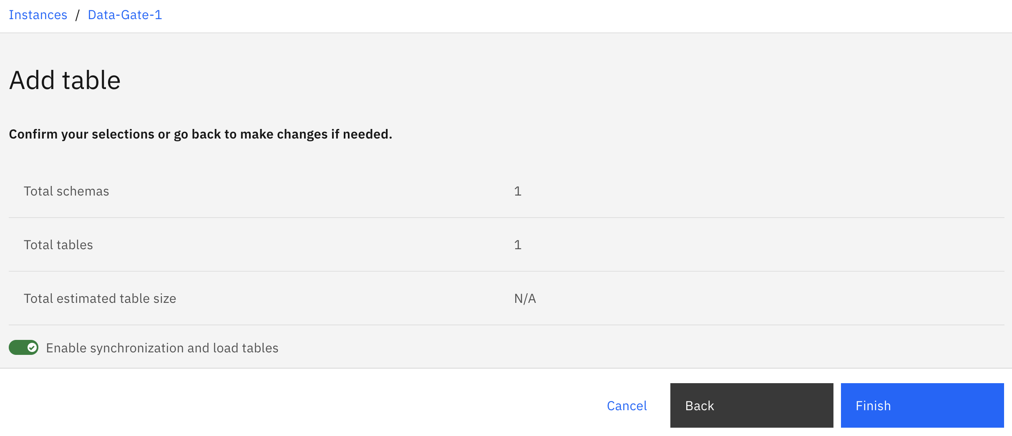

A wait dialog is displayed while the table is added.

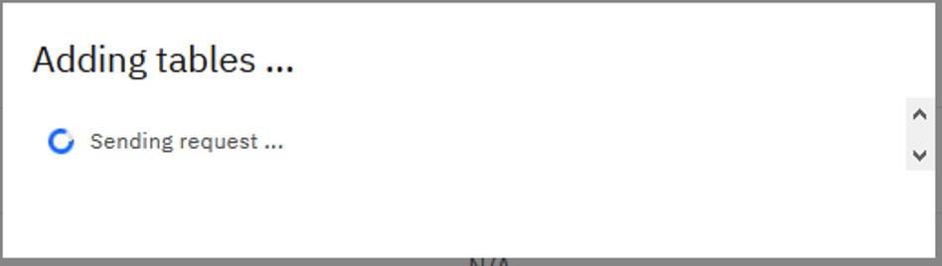

1. You are taken back to the Data Gate dashboard which displays the status of the tables. Scroll down to your table, or type <schema> into the Find tables search field to display your table’s status.

Depending on system activity from other users, your table will stay in a loading status for some number of seconds.

Note that while your table is loading, its load activity will not be reflected in graphs above the Tables list. These graphs monitor latency and throughput for updating z/OS tables that have previously been synchronized with Data Gate. With the most recent Data Gate release, network latency is also monitored and reflected in the graphs.

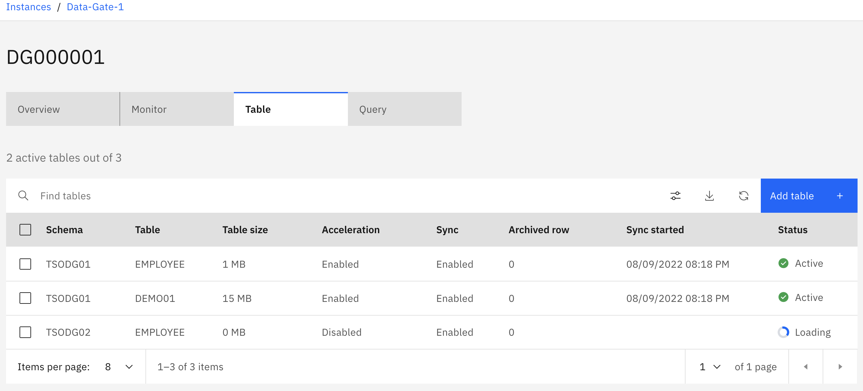

1. Once your table is loaded, its status changes to Active. At this point, Data Gate is monitoring changes on Db2 z/OS and will synchronize the changes with the table in the Db2 instance in CP4D.

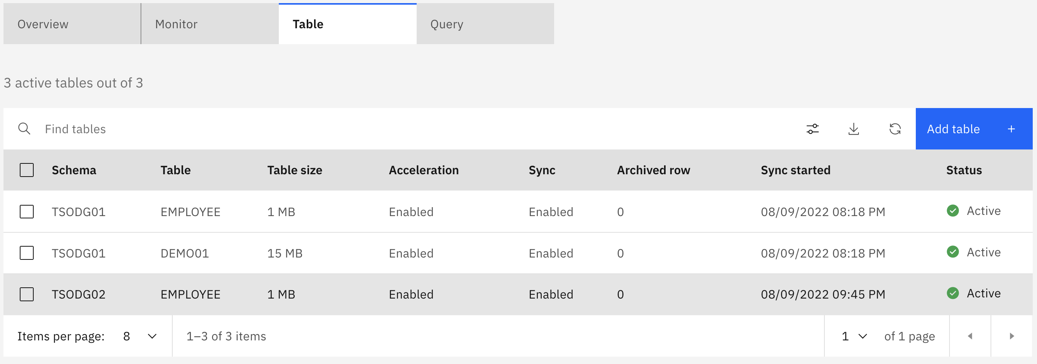

# 4 Learn how applications can exploit synchronized tables.

Now that you have enabled your table to be replicated by Data Gate, use the demo application to drive activity against your z/OS table and observe how Data Gate automatically synchronizes updates to the z/OS Db2 source table to the target table under Cloud Pak for Data.

The demo application represents a new enterprise application that is not necessarily on z/OS or in the CP4D cluster, but perhaps somewhere else in a business’s datacenter. It just wants to make use of the current z/OS data that is now replicated into the CP4D cluster via Data Gate.

1. From the Windows VM desktop where you are taking the lab, click on the <dg_demo_url> to open a new browser window, or enter the <dg_demo_url> into a new browser tab.

The demo application shown below should be displayed. The tables on the right show the data in your z/OS Employee table and its Data Gate synchronized (Target) table in the Db2 instance in the CP4D cluster. The gauges just to the left of each table indicate the record counts in their corresponding tables. If the tables are not on the right of the page, but instead, below the gauges, try maximizing your browser or zooming out with the browser controls.

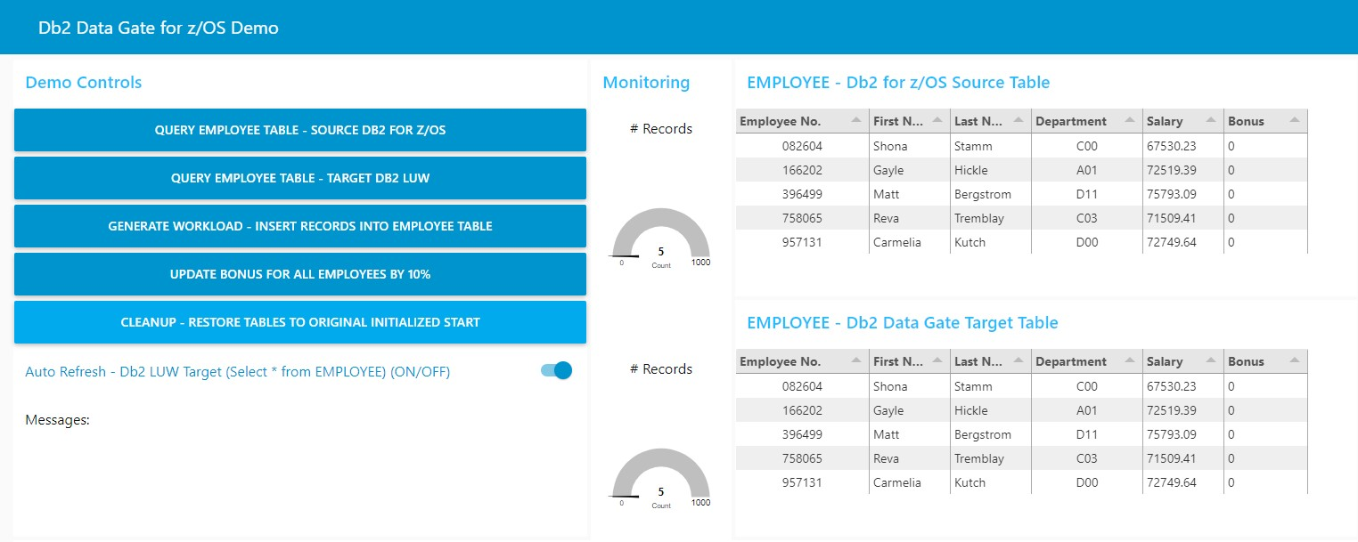

**NOTE**: If you get an error in red text in the Messages area at the bottom of the application, switch back to the Data Gate tab and check the Tables list to make sure your user’s EMPLOYEE table is listed, its Status is active, and Sync is enabled. If the table appears in Data Gate as described, click on the query buttons several times, which may clear a stale database connection. If that does not solve the problem, contact the lab instructor for help.

1. Enable refresh of the Target Employee table. This will allow you to observe changes to the Target table as updates occur against your z/OS Employee table.

* Click on the Auto Refresh slider button. The button should slide to the right and change to blue.

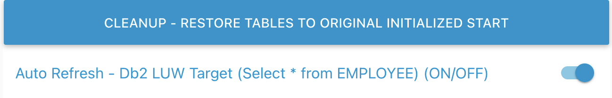

1. Observe synchronization behavior of new record inserts. Click on the GENERATE WORKLOAD button (A) to insert new records into the source EMPLOYEE table on z/OS table.

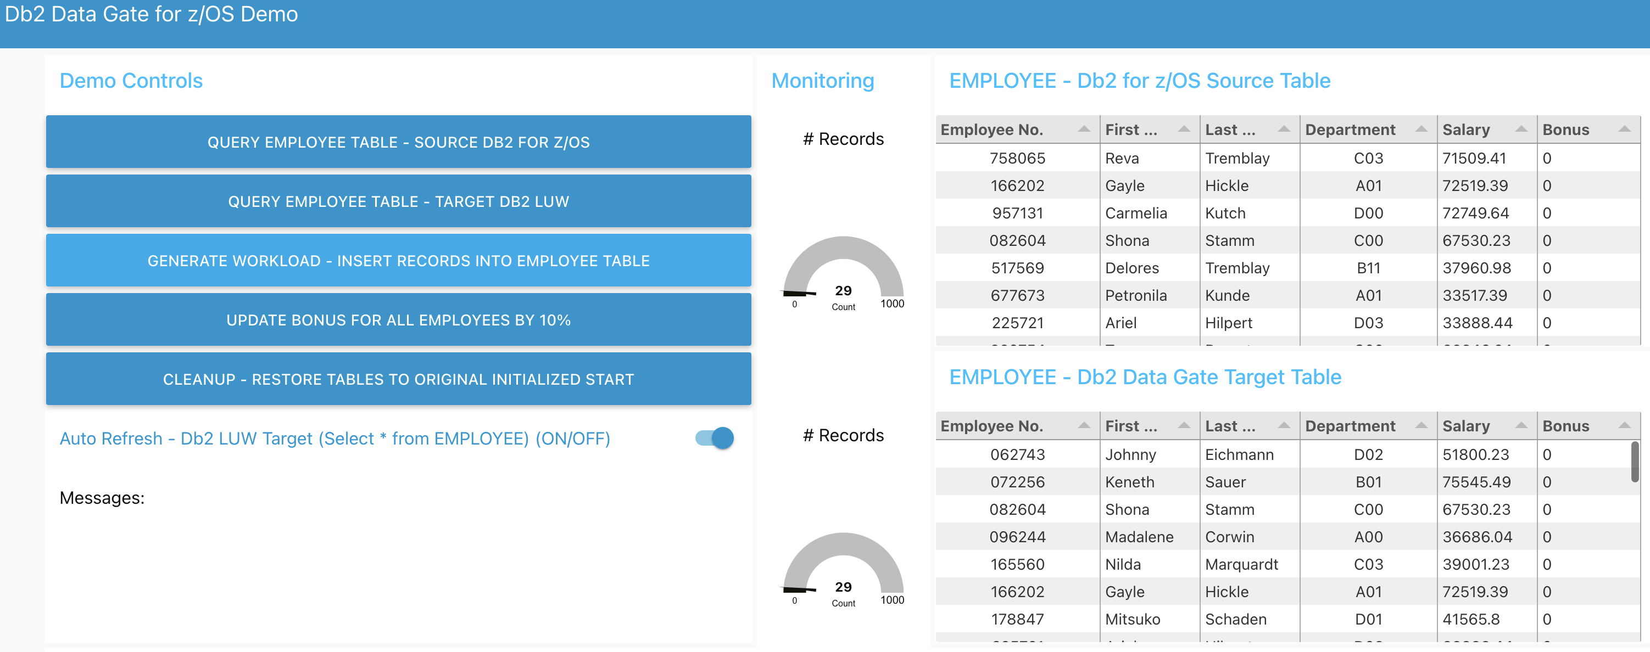

C

B

A

You should observe immediate updates to (B) the top z/OS table and record count gauge. Shortly after, the target table and record count gauge (C) should reflect the same updates.

You can click on the GENERATE WORKLOAD button several more times to further observe how changes to the source table are quickly reflected in the target.

**Note**: If you continually click on the GENERATE WORKLOAD button, due the design of the demo application framework, it cannot run the query to update the contents of the target table and gauge. This causes increased delays in reflecting updates to the target table.

1. Monitor the synchronized Employee table as updates are made to existing records.

Click on the UPDATE BONUS FOR ALL EMPLOYEES BY 10% button (A). You should immediately see updates to the source table Bonus column (B), then shortly after, updates to the target table Bonus column (C)

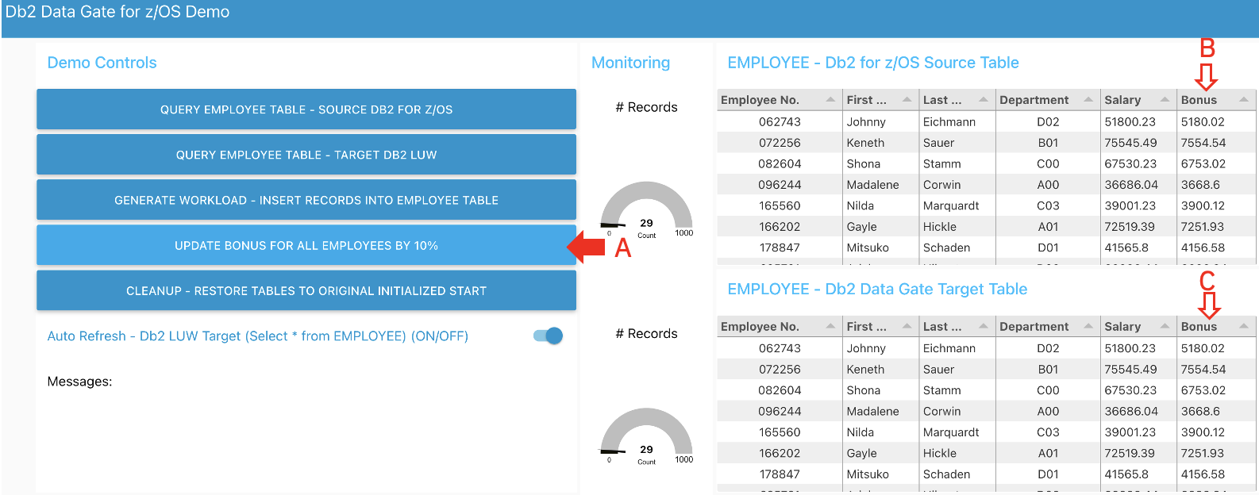

Disable monitoring of the target Employee table.

* Toggle the Auto Refresh slide button at the bottom of the action buttons to stop Auto Refresh

1. Check Data Gate synchronization graphs to see how application database activity is reflected in the synchronization monitoring graphs.

* Click on your CP4D browser tab to navigate back to the CP4D UI. Navigate back to the Data Gate instance Monitor tab, showing the data synchronization graphs.

As you (and other students) generate activity, the data movement is monitored and reported on these graphs to help you understand the volume of data being moved to your Data Gate tables, and how much delay there is in moving the data.

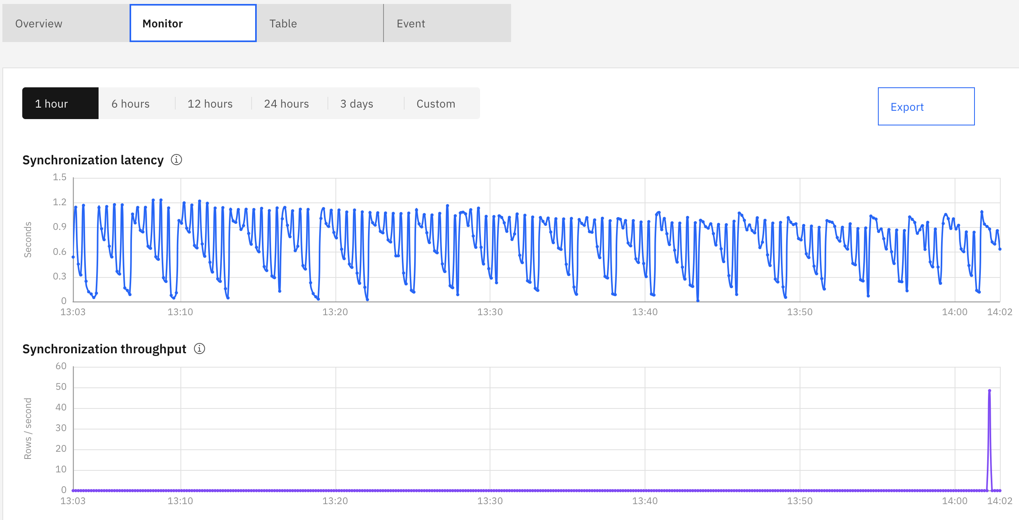

Click on any of the data points on these plots to see the specific synchronization latency and throughput measurements for that time point.

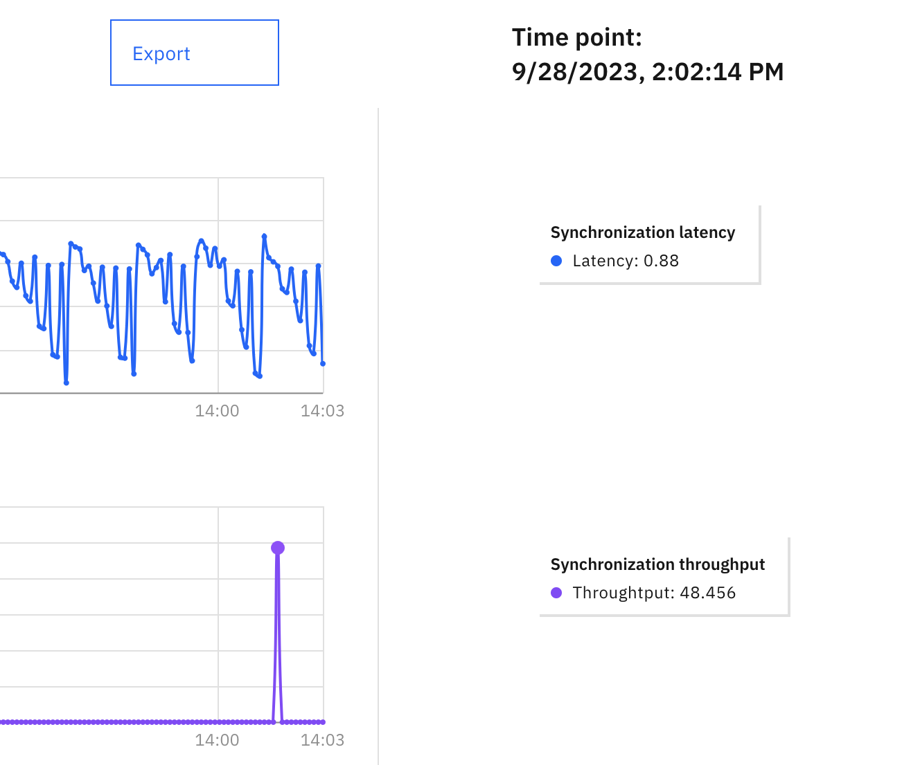

This concludes this section. You now understand how Data Gate allows administrators to easily select and enable replication of source z/OS Db2 tables in Cloud Pak for Data. The target tables can be used by business application that need current z/OS data while causing minimal impact to your z/OS Db2 subsystem and existing applications.

# Observe “bulk” replication in action

In this section, you will add a table to Data Gate and run a job that inserts 500K rows into the source table on z/OS. You can observe the latency and throughput for synchronizing updates between the source z/OS Db2 table and the target table created by Data Gate in the CP4D Db2 instance.

## Add the “Demo” table to your Data Gate instance

1. Open the Add table dialog

* Click on the Add table button on the top of the Tables list

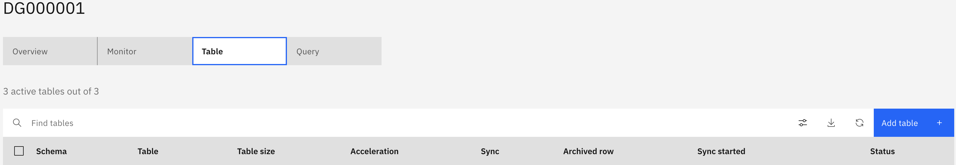

On the Add Table page that comes up, do the following

* Enter <schema> into the Schema search and hit enter (1)
* Click the mouse where arrow #2 indicates, which should cause the list of tables under your schema to appear (2)
* Check the DEMO<nn> table from the list that appears in the middle (3)
* Ensure that DEMO<nn> is the only table that is selected in the list on the right (4)
* Click the next button at the bottom-right

**Note**: If your DEMO table does not show in the list of available tables to add, it has likely already been added to Data Gate list of synchronized tables.

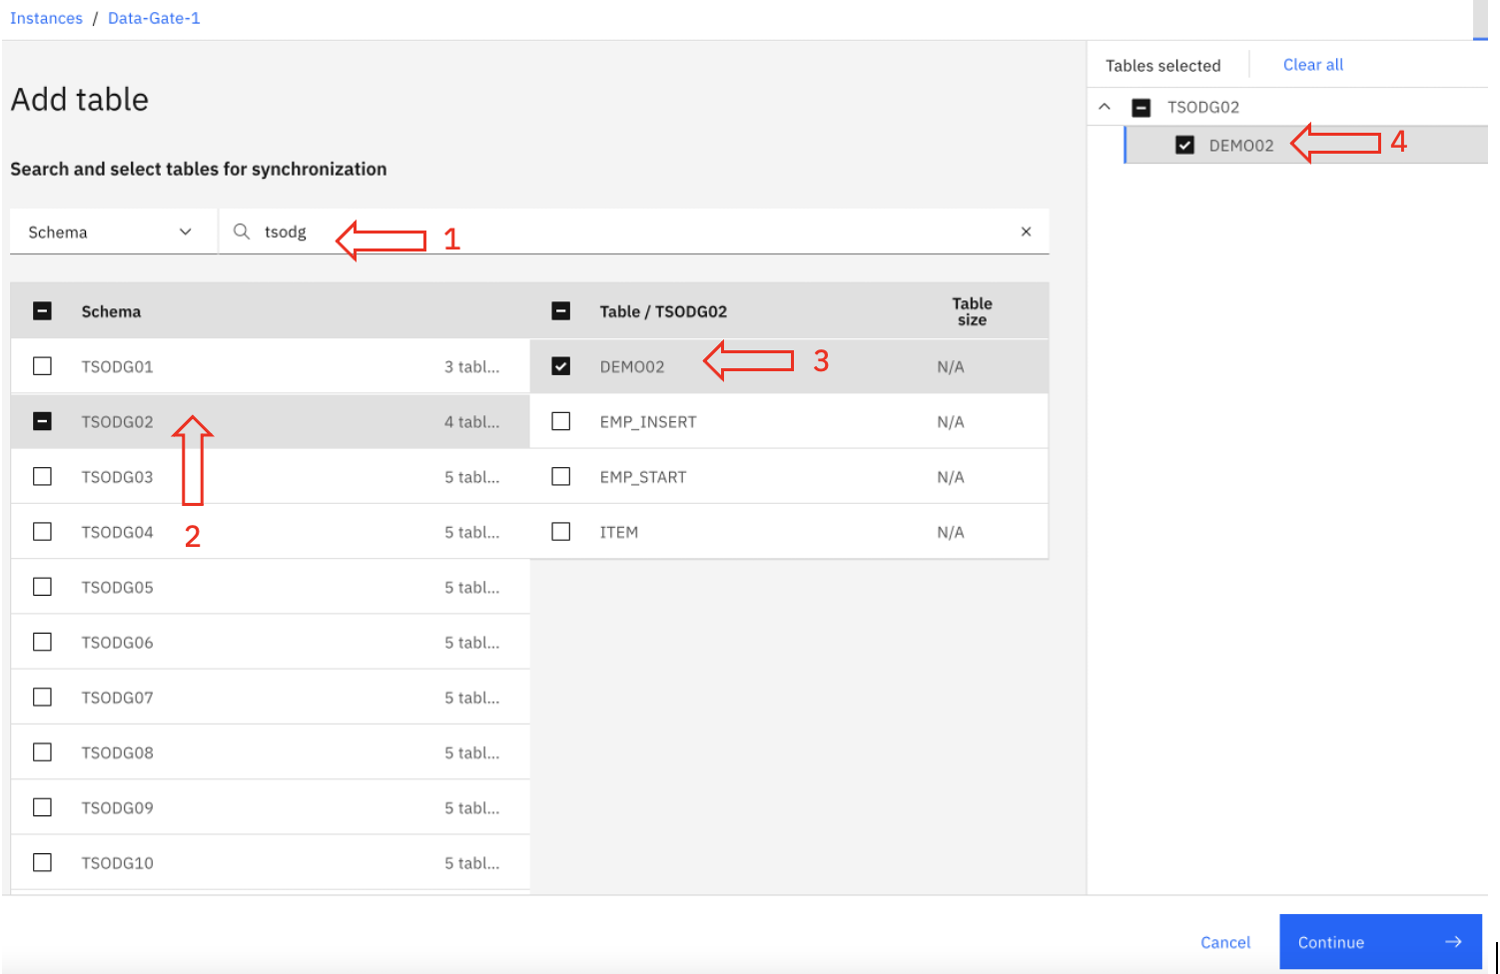

* On the next page, ensure the Enable synchronization and load tables slide button is enabled and click the Finish button to add your DEMO table.

1. Confirm your table has been created and is ready

* Type <schema> into the table filter field and hit enter.
* Your DEMO<nn> table should appear. Take note of its size to compare it later after you have loaded new data into the z/OS table source table.
* Ensure that Sync is enabled, and the Status is Active before proceeding.

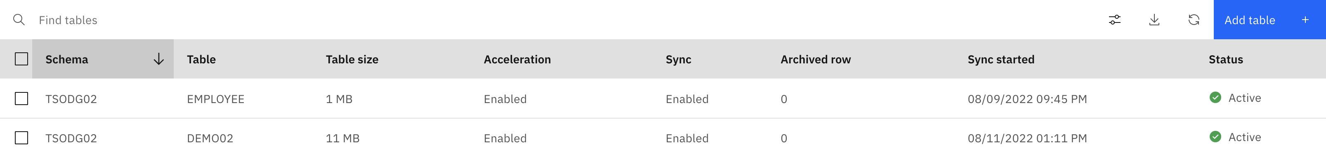

## Load Data into the newly synchronized table

1. Connect to z/OS using Zowe Desktop.

* Double-click the Zowe Desktop icon in the CP4D fold on your virtual desktop. It may take several seconds to initialize



* You will be taken to the Zowe Desktop login screen. Use <login_userid> and <login_password> as the credentials and click Login.

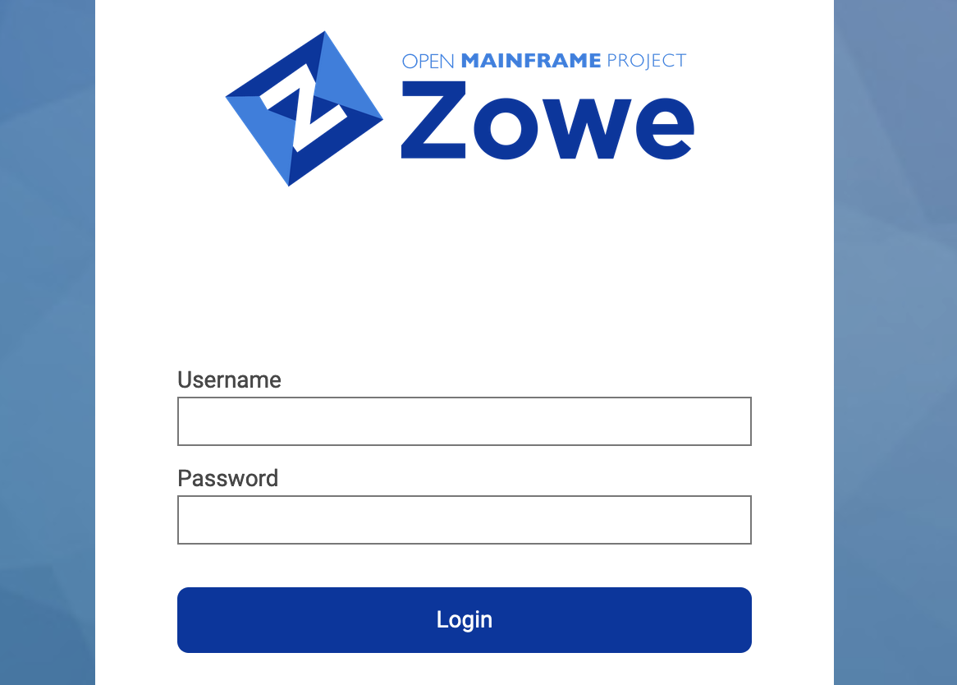

1. Open your user ID’s JCL library

Once logged in, you will be shown a desktop interface with nothing yet opened.

* Click on the ‘Z’ icon in the bottom left-hand corner of the desktop

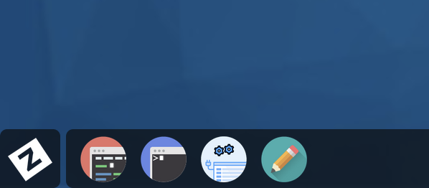

* Here you can see several applications provided by Zowe Desktop to interact with IBM mainframes in alternative ways other than tn3270 terminals. Select the MVS Explorer option which simplifies editing datasets and submitting jobs.

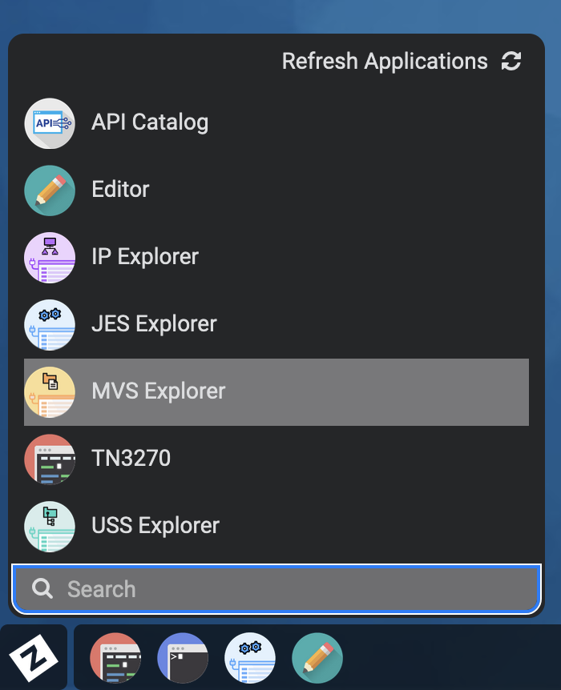

* With the MVS Explorer open, you will automatically be shown datasets under your High Level Qualifier, in this case your <login_userid>. Open your JCL library by clicking on your <login_userid>.JCL.CNTL dataset displayed.

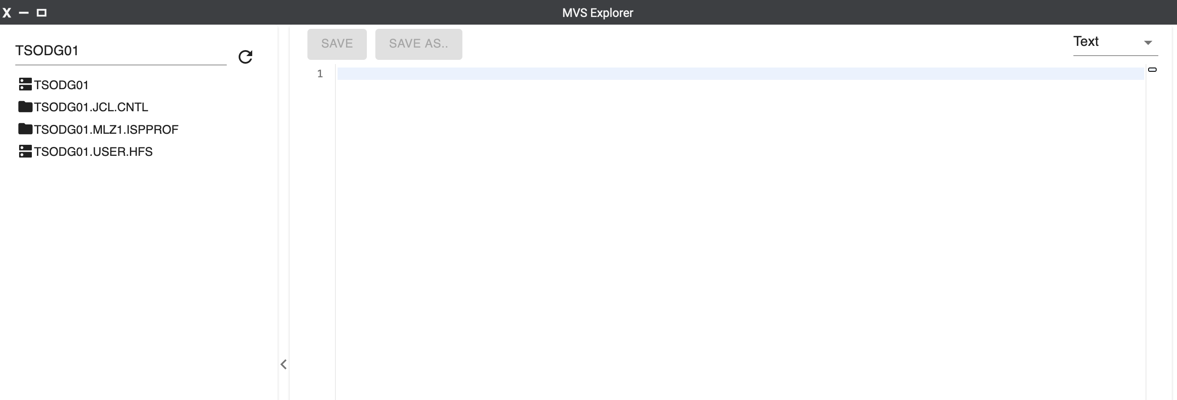

* Here you can see the datasets present within your lab user’s JCL library. Click on the RUNDEMO<nn> member. The contents of the dataset will be shown.

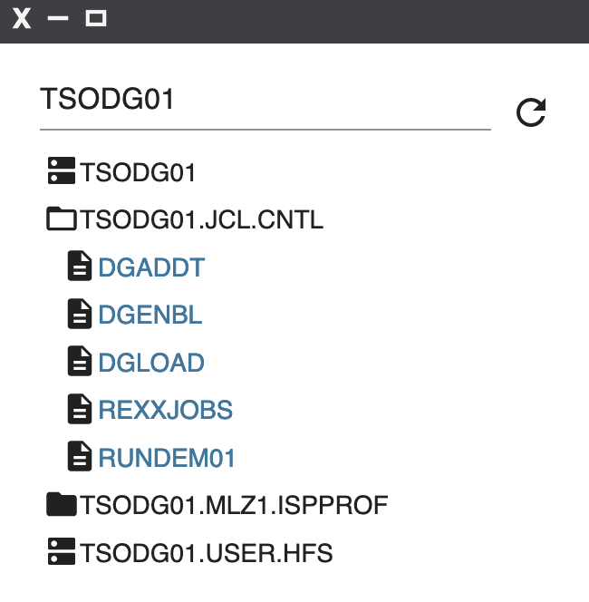

1. Run bulk load job

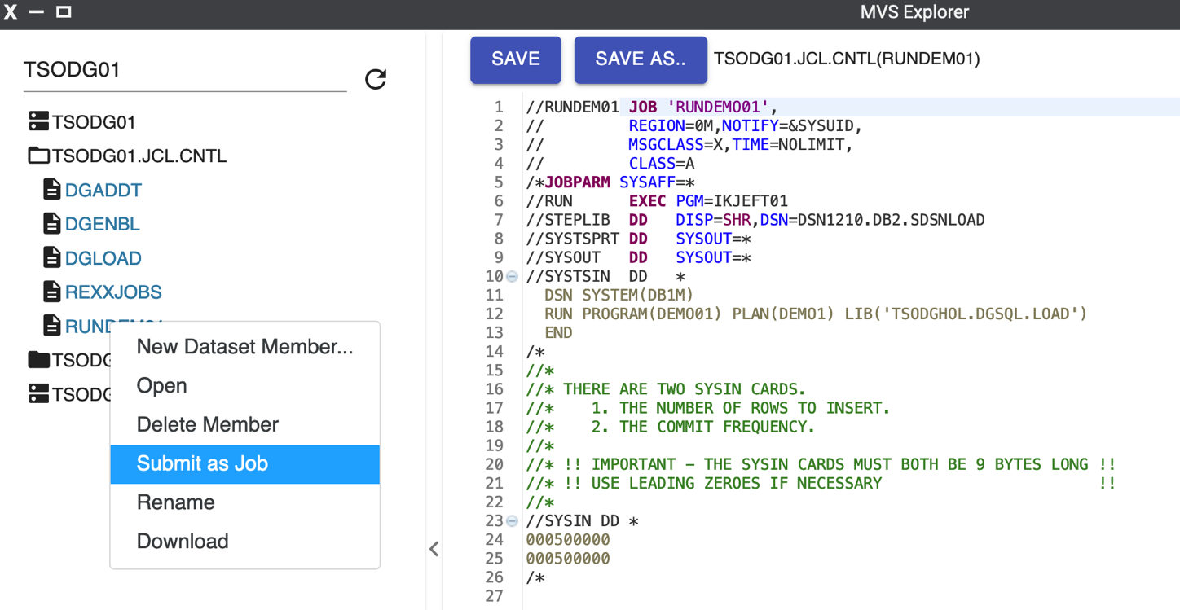Right mouse button click on the RUNDEMO<nn>.jcl member and select the Submit as Job action.

A job submission dialog will appear informing you that the job submission was successful.

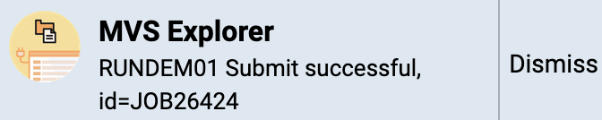

1. Check the status of the job.

Click on the JES Explorer icon from the bottom task menu of Zowe Desktop to confirm the job completed successfully.

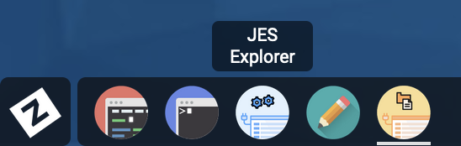

1. View your job output

* Once JES Explorer is open, you will be shown jobs that your user has submitted. Expand the first row, which should be appended with the text [CC 0000] indicating a zero completion code and successful execution.
* Click on SYSOUT to see the job output message indicating how many rows have been inserted into the Db2 for z/OS database.

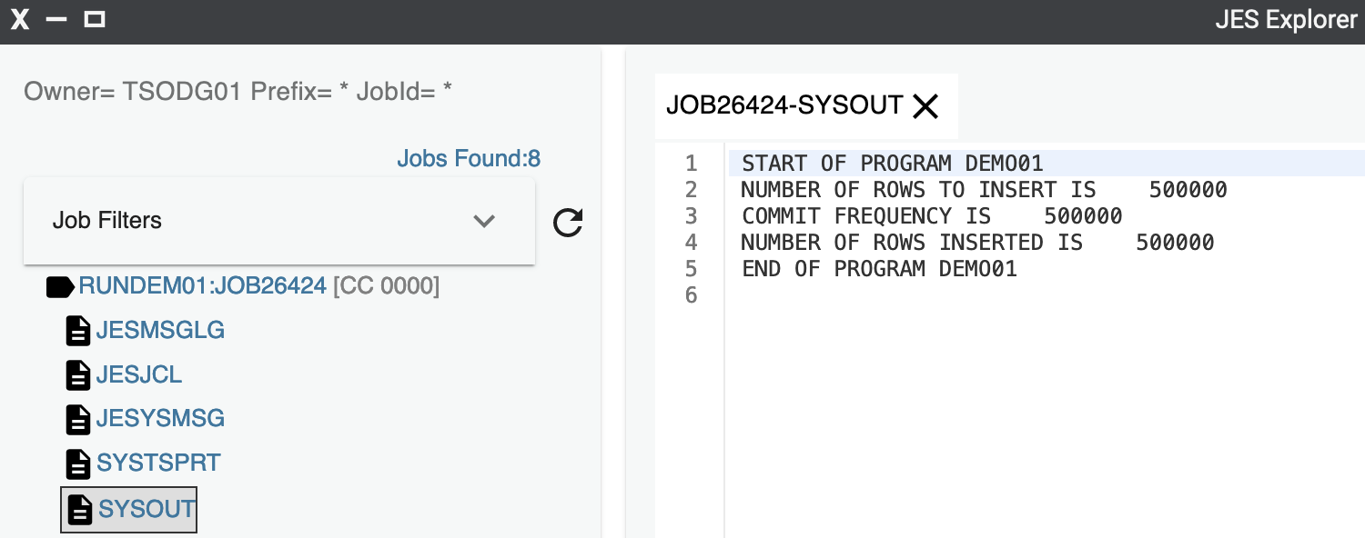

1. View the table synchronization metrics in the Data Gate dashboard

* Switch back to the browser where the Data Gate Monitor dashboard is displayed.

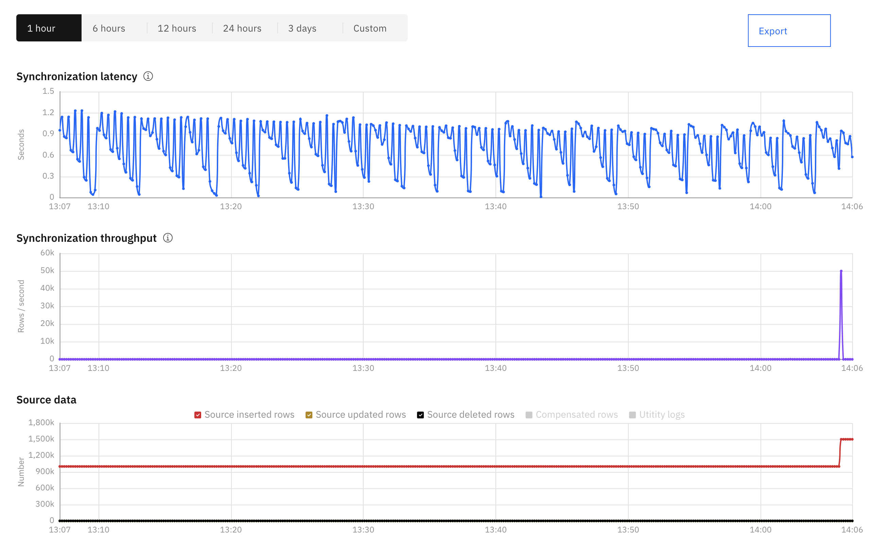

The latency and throughput graphs should reflect low-latency, high throughput synchronization of the z/OS data. Scrolling down further to the Source and Target data plots you should see a ‘step-function’ showing 500,000 rows being inserted in the source Db2 for z/OS and soon after, 500,000 rows being inserted in the target Db2 LUW

## Use the Db2 Console to query CP4D table data (Optional Section)

While the main purpose of Data Gate is to efficiently synchronize your z/OS data for off platform consumption of business applications, you can use other features of CP4D to check the content of the tables that are being hosted in CP4D.

1. Switch to the Db2 console for the database instance that is storing your table data.

* Click on the “hamburger” Navigation menu at the top-left of the CP4D browser window

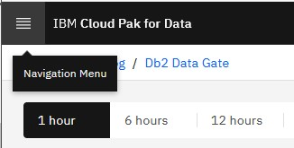

* Select Databases from the drop-down menu

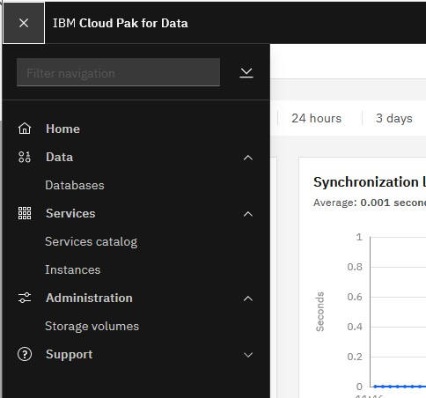

* Click on the action menu at the top-right of the Db2-1 database icon and click Open database.

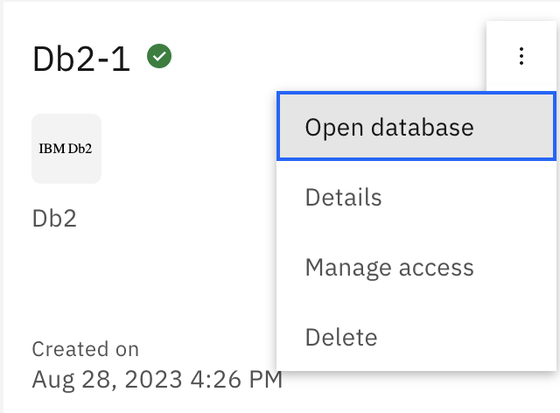

You should be presented with a “Summary” view of the database. Here you can see important metrics related to the Db2 Warehouse including, availability, responsiveness, throughput, resource usage, contention, and how time is being spent.

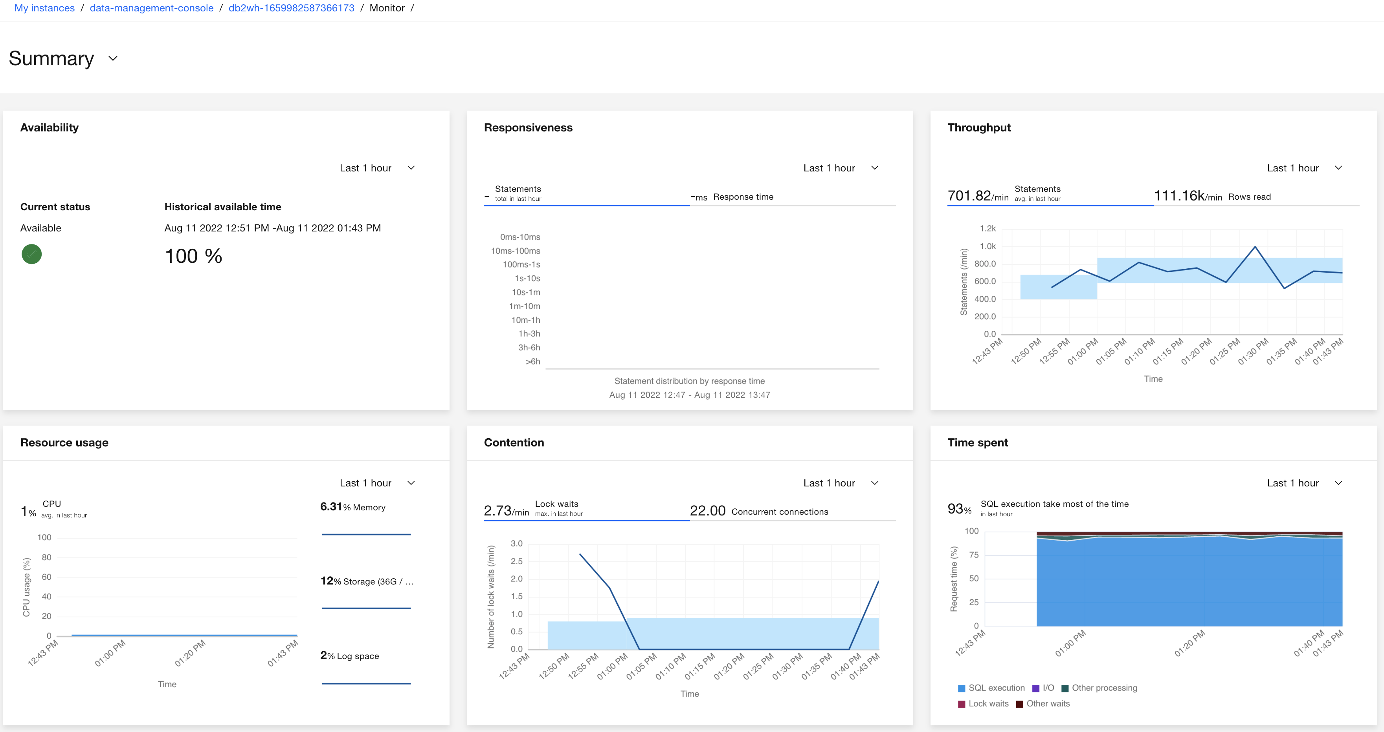

1. Switch to the Run SQL section

* Click the drop down “caret” left of the “Summary” text in the top-left corner. Select the Run SQL section.

1. Select Aliases

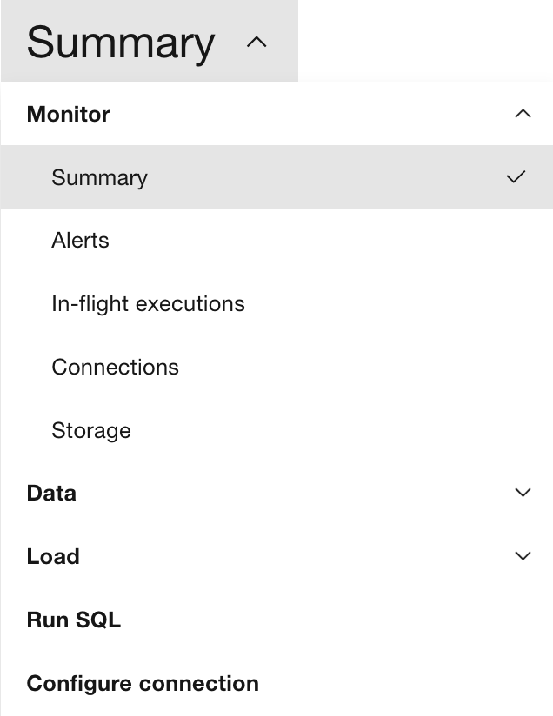

1. Identify your table’s alias

* Type in your <schema> into the filter tool
* In the left data object list, select your <schema>
* Expand the list of aliases below and select your DEMO<nn> table name

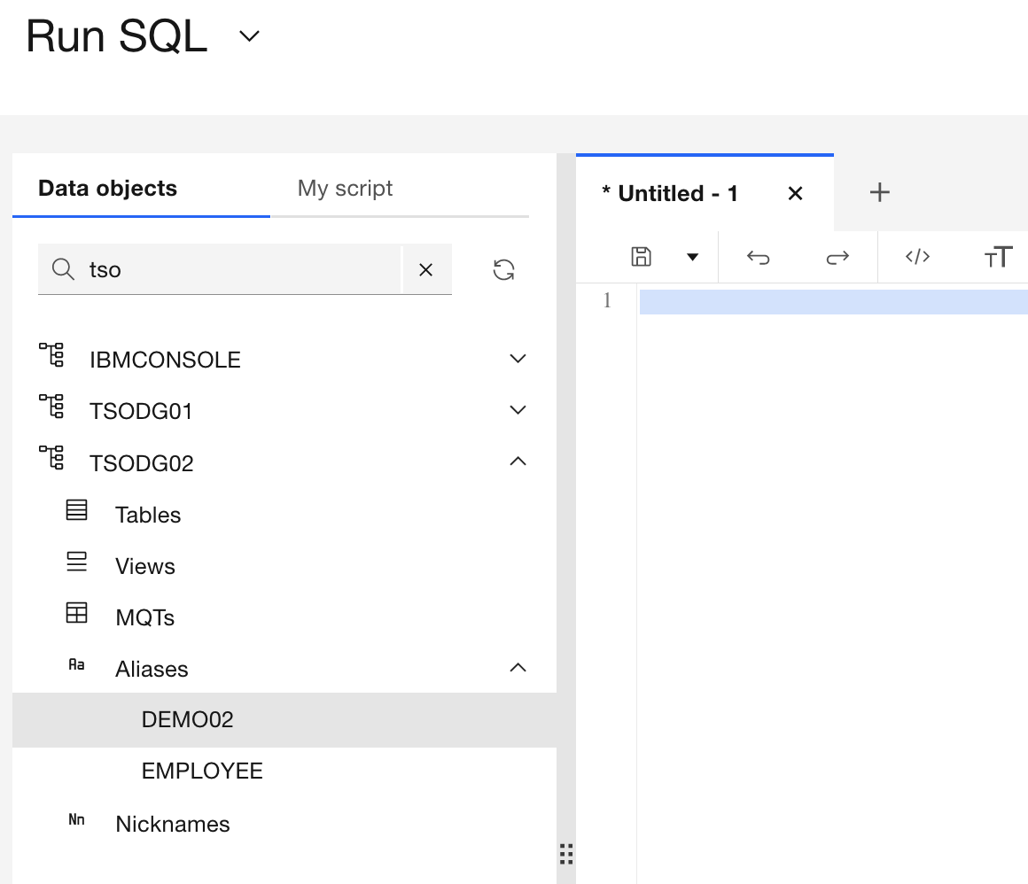

1. Open SQL query tool against your table alias

* Right click on your DEMO<nn> table name icon to display the drop-down menu
* Select Generate DML

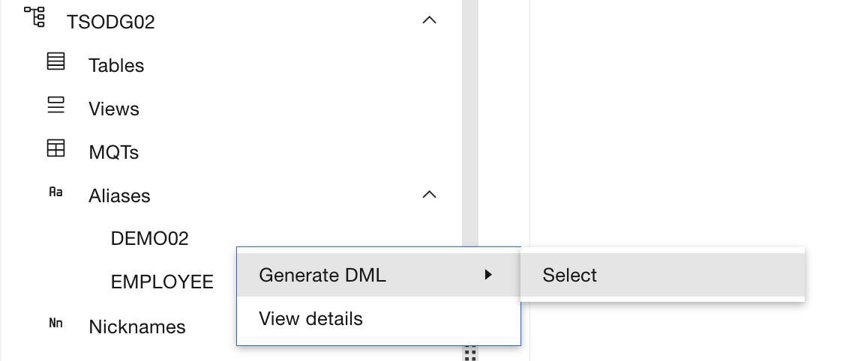

* In the Statement type dialog that comes up, chose Select

1. Modify, and run the SQL statement

* Edit the first line of the SQL statement to be SELECT COUNT(*)
* Click the Run all button

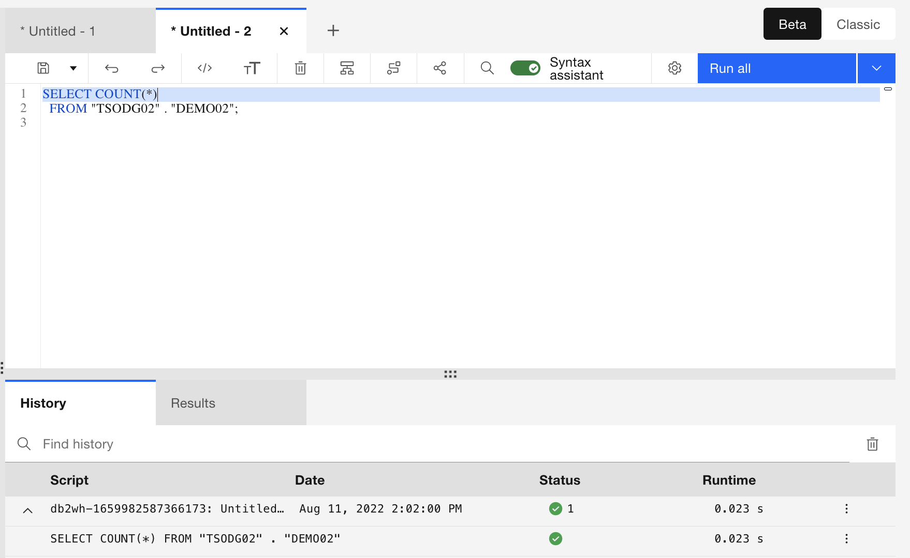

The query will take a moment to run. Click on the Results tab to see the count the SQL statement returned. It should show that your table has at least 500000 records in it.

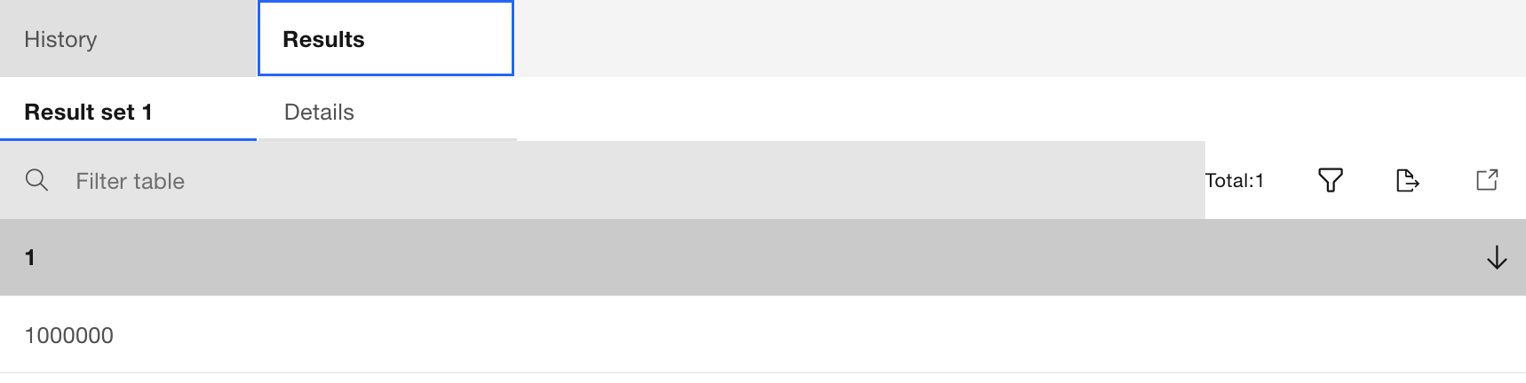

End of section.

# Use Db2 for z/OS Data Gate Store Procedures with REXX

While the Data Gate table management UI provides an effective and easy way to add and remove tables from Data Gate, there may be times where a capability to add or remove tables in a batch or automated manner is required.

In this section, you learn how you can use REXX to call Data Gate stored procedures to add a table, enable synchronization of its data between z/OS Db2 and Data Gate, and then do the initial load the data from z/OS to Data Gate.

**Action, job, and Data Gate stored procedure:**

|  |  |  |  |  |  |  |
| --- | --- | --- | --- | --- | --- | --- |
| **Action** | **Job** | **Stored Procedure** | | | | |
| **Add table** | **DGADDT** |  | **DATAGATE_ADD_TABLES** |  | | |
| **Enable Synchronization** | **DGENBL** |  | **DATAGATE_SET_TABLES_REPLICATION** | | |  |
| **Load table** | **DGLOAD** |  | **DATAGATE_LOAD_TABLES** | |  | |

A critical piece of information needed to invoke these stored procedures is the name of the Data Gate “instance” which is established when you connect a CP4D Data Gate instance to your z/OS Db2 subsystem. Db2 uses this “instance” name to refer to key information required to run the stored procedures against the desired Data Gate instance in the CP4D cluster.

This name is found by running the Db2 DISPLAY ACCEL command, typically issued from the z/OS console. For your convenience, we have included the Data Gate instance name as <dg_instance> in your lab worksheet.

The next subsection will step you through customizing some of the critical elements of the stored procedure calls.

## Customizing and submitting Data Gate stored procedure jobs

Zowe Desktop should already be open from the previous exercise. If not please return to Section 4.2 and follow the steps to access Zowe Desktop and MVS Explorer.

__37. Open your user ID’s JCL library

* If not already opened, click on the yellow MVS Explorer icon on the bottom task bar.

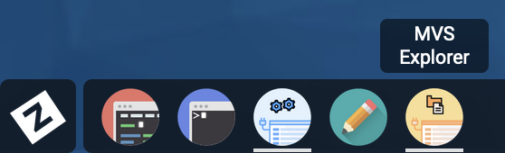

* With the MVS Explorer open, you will automatically be shown datasets under your High Level Qualifier, in this case your <login_userid>. Open your JCL library by clicking on your <login_userid>.JCL.CNTL dataset displayed.



__38. Customize the add table job

* Open the add table job by Double clicking on DGADDT from your user’s JCL library.

The job will open in a MVS Explorer editor window.

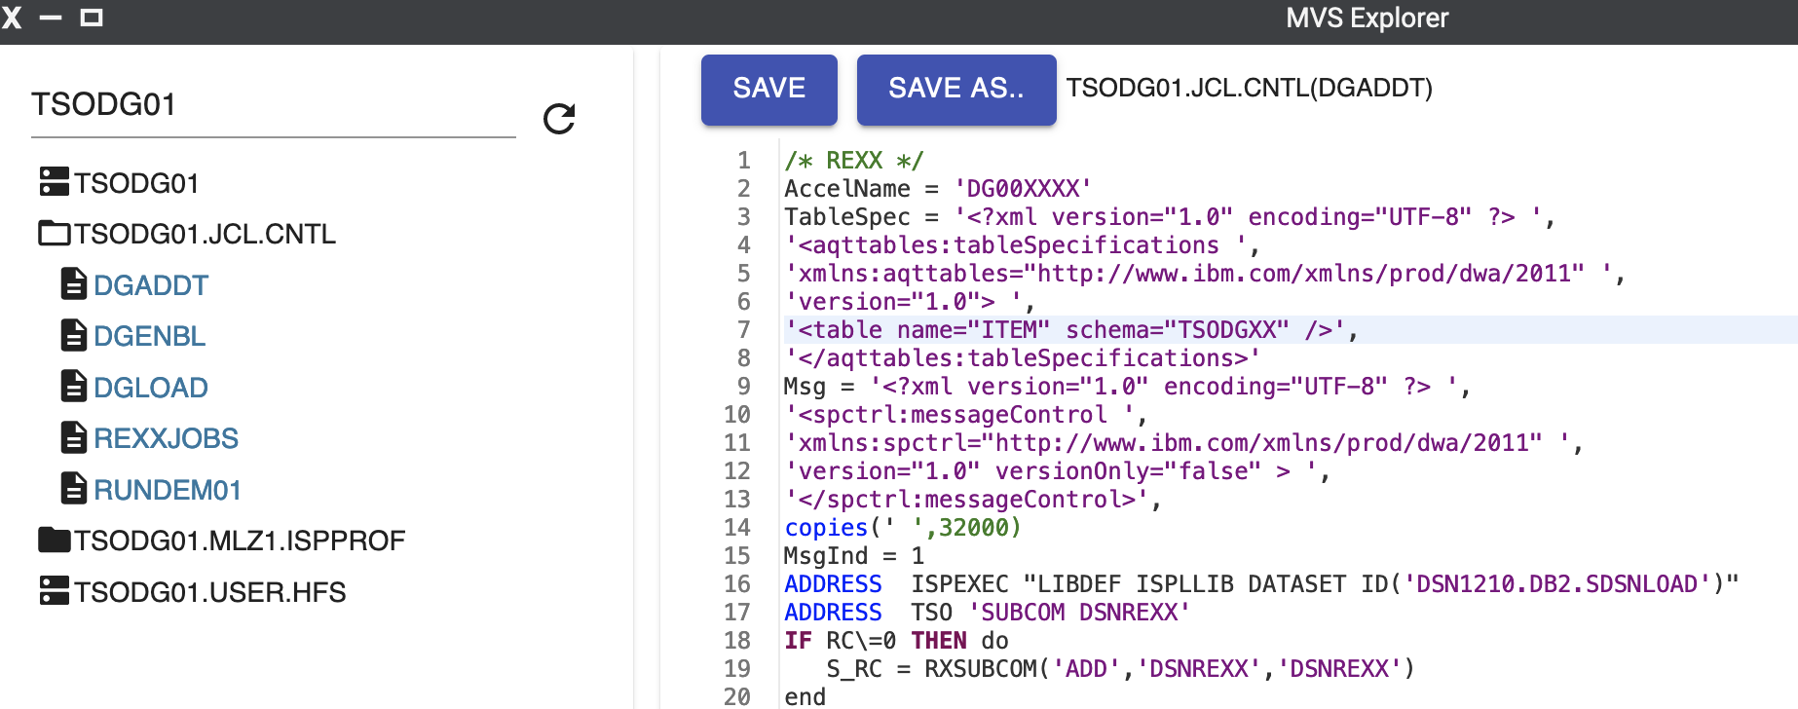

Two changes are required in this job. The locations of the changes have been highlighted in the image below.

* The AccelName value needs to be set to <dg_instance>. Make sure to keep the single quotes
* The schema value needs to be set to <schema>. Make sure to keep the double quotes.



* Click the “save” icon 2nd from the left at the top of the menu bar

__39. Customize the enable synchronization job

* Open the enable synchronization job by Double clicking on DGENBL in your user’s JCL library.
* Update schema’s value (highlighted) to <schema> . Make sure to keep the double quotes.

NOTE: the AccelName value (<dg_instance>) in your worksheet may be different than what is displayed in these images. Use what is in your worksheet.

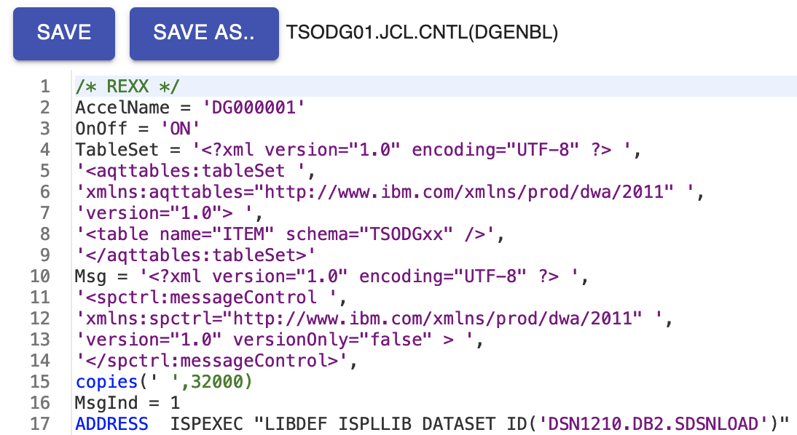

* Just as with the previous job, save the job and close the editor.

__40. Customize the load table job

* Open the load table job by Double clicking on DGLOAD.
* Update schema’s value (highlighted) to <schema> . Make sure to keep the double quotes.

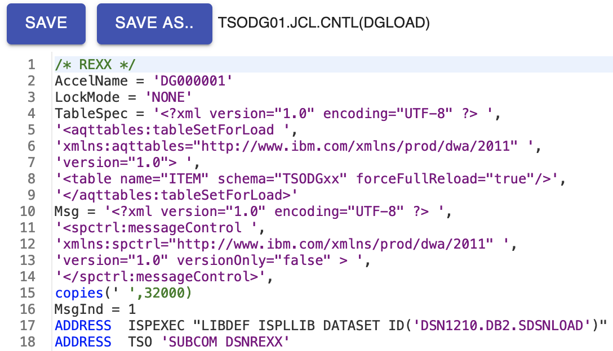

* Just as with the previous job, save the job and close the editor.

__41. Customize the REXX submission job

* Open the REXX submission job by Double clicking on REXXJOBS
* Update the highlighted ‘XX’ characters with your user ID’s 2-digit numeric suffix represented as <nn> on your worksheet.

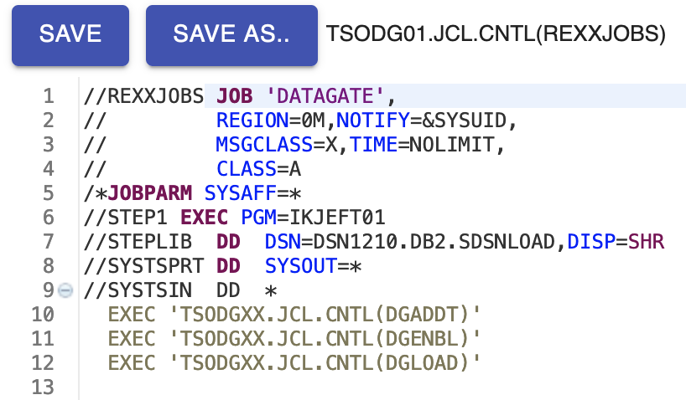

* Just as with the previous job, save the job and close the editor

__42. Submit the REXX job

* Right mouse button click on the REXXJOBS member and select the Submit as Job action.

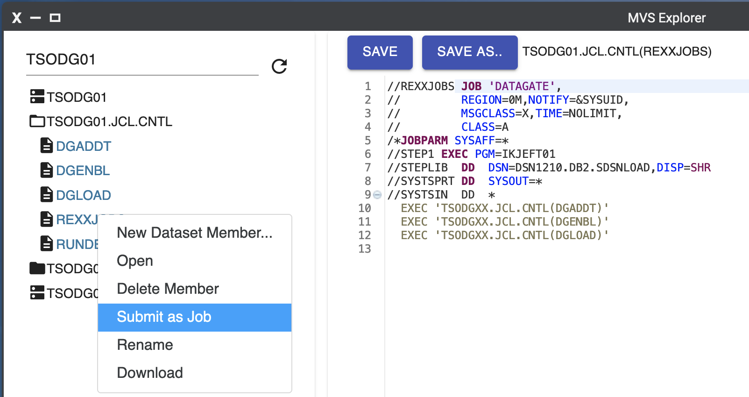

* You should get an indication that the job was submitted successfully

__43. Check the status of the job.

Click on the JES Explorer icon from the bottom task menu of Zowe Desktop to confirm the job completed successfully.



__44. View your job output.

* Once JES Explorer is open, you will be shown jobs that your user has submitted. Expand the top row titled REXXJOBS, which should be appended with the text [CC 0008]. Do not be concerned about the non-zero return code, this is a result of the XML parsing.
* Click on SYSTPRT and look through the job output which will tell you if each step in the REXX script successfully completed.

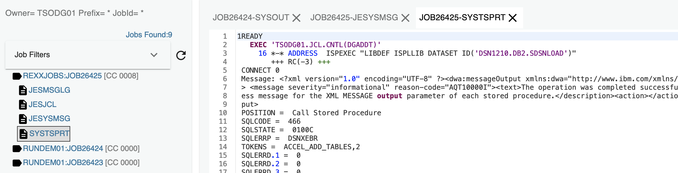

__45. Switch back to Data Gate UI to verify your table has been replicated from z/OS to your Data gate Instance. You should see a table named ITEM under your assigned <schema>.

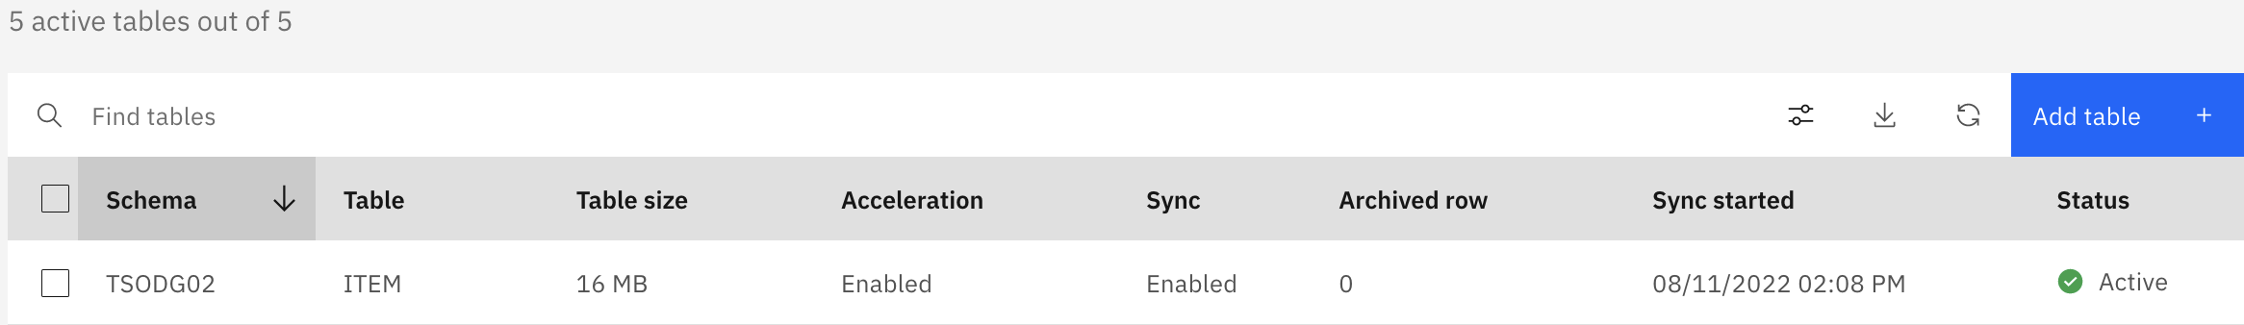

End of section.

# Using Db2 for z/OS data in watsonx.data with Data Gate

## Watsonx.data introduction

Now, with your Db2 for z/OS data synchronized off-platform, you may want to perform analytical queries, or train AI models with this data. You can of course perform these analytical queries on the CP4D platform using the Data Management Console, or you can train an AI model within CP4D’s Watson Studio. However, there may be certain business use-cases, such as training generative AI models, where you need to leverage a massive amount of data stored across your enterprise’s data stores. IBM has developed the watsonx platform to address these challenges.

Watsonx.data is a core component of watsonx, IBM’s enterprise-ready AI and data platform designed to multiply the impact of AI across an enterprise’s business. The watsonx platform comprises of three powerful components: the watsonx.ai studio for new foundation models, generative AI and machine learning models; the watsonx.data fit-for-purpose data store that provides the flexibility of a data lake with the performance of a data warehouse; plus the watsonx.governance toolkit, to enable AI workflows that are built with responsibility, transparency, and explainability.

The watsonx.data component (the focus of this lab section) makes it possible for enterprises to scale analytics and AI with a data store built on an open lakehouse architecture, supported by querying, governance, and open data and table formats, to access and share data. With watsonx.data, enterprises can connect to data in minutes, quickly get trusted insights, and reduce their data warehouse costs. Below, in Figure 2, you can see a view into watsonx.data’s lakehouse architecture.

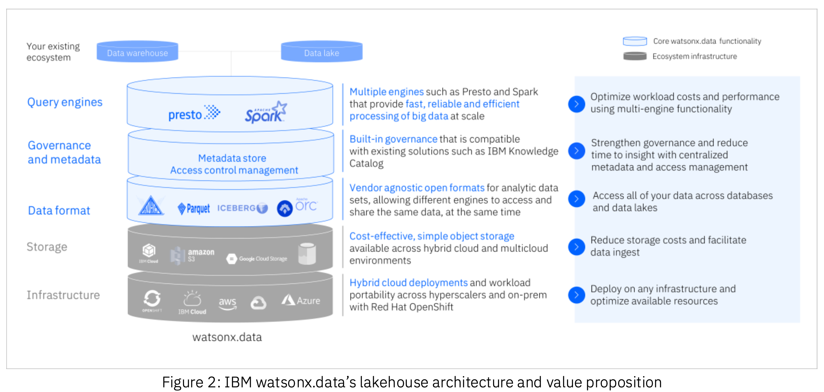

Watsonx.data is based on Presto, an opensource distributed query engine that enables querying data stored in open file formats using open table formats for optimization or performance. Other query engines can be used as well, including Db2, Spark, and Netezza. This allows you to pair the appropriate workload with the most performant query engine for that use case. For example, you would want to use Spark for AI workloads, and Presto for business intelligence projects. With watsonx.data, you could query the same data at the same time by using two different query engines.

Presto is a distributed SQL query engine, with the capability to query vast data sets located in different data sources. Presto is designed for scale; for example, a company used Presto to power 100 million queries per day with 7,000 weekly active users on a 50 PB data lake.

Some of the performance characteristics of Presto include:

* Compute processing is performed in memory and in parallel.
* Data is pipelined between query stages and over the network reducing latency overhead that one would have if disk I/O were involved.

Presto provides the ANSI SQL interface, which can be used for all data analytics and watsonx.data use cases. With this feature, you do not need to manage multiple query languages and interfaces to different databases and storage. Presto is designed for storage abstraction, which allows connections to any data source through its connectors. Currently, watsonx.data uses version 0.279 of Presto.

Common use cases for Presto include:

* Extemporized querying
* Reporting and dashboarding
* Transformation using SQL
* Analytical querying
* Federated querying across multiple data sources

Vendor agnostic table formats are used within watsonx.data, preferably the Apache Iceberg format. Iceberg is a high-performance format for huge analytic tables.  Iceberg adds tables to compute engines including Spark, Trino, PrestoDB, Flink, Hive and Impala using a high-performance table format that works just like a SQL table.  Iceberg is used in production where a single table can contain tens of petabytes of data and even these huge tables can be read without a distributed SQL engine.

Open data formats such as Parquet and ORC are supported on the platform. Existing data can be loaded into the watsonx.data platform and stored in these formats through a database connection, a file upload, or an ingestion job.

Connectors are provided to connect to existing databases, data warehouses, or data lakes. As of this writing, the following connections are supported in watsonx.data:

* [Iceberg](https://prestodb.io/docs/current/connector/iceberg.html)
* [Db2](https://cloud.ibm.com/docs/watsonxdata?topic=watsonxdata-db2_connector)
* [Netezza Performance Server](https://cloud.ibm.com/docs/watsonxdata?topic=watsonxdata-netezza_connector)
* [Hive](https://prestodb.io/docs/current/connector/hive.html)
* [JMX](https://prestodb.io/docs/current/connector/jmx.html)
* [Kafka](https://prestodb.io/docs/current/connector/kafka.html)
* [Memory](https://prestodb.io/docs/current/connector/memory.html)
* [MongoDB](https://prestodb.io/docs/current/connector/mongodb.html)
* [MySQL](https://prestodb.io/docs/current/connector/mysql.html)
* [PostgreSQL](https://prestodb.io/docs/current/connector/postgresql.html)

This lab uses the watsonx.data Developer Edition, which includes an embedded instance of MinIO, an open-source S3-compatible object store. However, you can also register and use external object storage buckets that you have created elsewhere (such as in IBM Cloud or Amazon Web Services). By using object storage, significant cost-savings can be realized. Watsonx.data can be installed in any hybrid cloud environment where Red Hat OpenShift is supported, and is available as SaaS.

Connectivity to watsonx.data can be done using the following technologies, among others:

* Command line interface(CLI)
* Windows, Linux, OSX
* JDBC drivers
* Python
* watsonx.data UI

Now let’s explore the watsonx.data platform.

## Accessing the watsonx.data UI

1. Open the “**Db2 Data Gate for zOS**” folder on the virtual desktop and double-click the “**watsonx.data**” Link. Note: If this is the first time the browser has been opened on your VM, it may take over 10 seconds to start.

Alternatively, enter the **<watsonx_url>** link from your lab worksheet into the Firefox browser which should be on the desktop.

If you receive a security warning, accept the exceptions to proceed to the login screen. For Firefox, click the Advanced button, and then click Accept the Risk and Continue button.



1. In this lab environment, watsonx.data is installed as a service in Cloud Pak for Data (in a different CP4D installation than the one previously used in the lab).

The CP4D web client GUI displays as shown. Use <login_userid> and <login_password> as the credentials and click Log in.

Note that the credentials are case sensitive. Also, if you paste the password in, make sure there are no trailing blanks



Once logged in, you will see the welcome page of CP4D.



1. Click on Instances from the quick navigation section on the left-hand side of the welcome screen.



1. If you see an error message at the top of the screen, hit the refresh button on your browser. Here you see the service instances that have been provisioned in CP4D. Click the 3-dot action menu to the right of the instance titled ‘lakehouse’ and select ‘Open’. The watsonx.data UI will open.

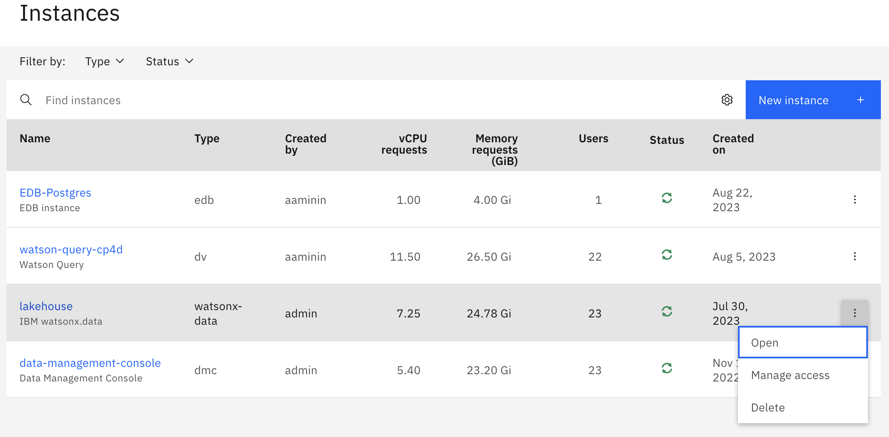

1. You are shown the watsonx.data home page. Included on the page are the following panels:
   * **Welcome**: Introductory information, including a link to documentation
   * **Infrastructure** **components**: A summary of the engines, catalogs, buckets, and databases that are registered with watsonx.data
   * **Recent** **tables**: Tables that have recently been explored
   * **Recent** **ingestion** **jobs**: Jobs that have recently moved data into watsonx.data
   * **Saved** **worksheets**: Frequently run queries saved as worksheets, for easier reuse
   * **Recent** **queries**: Queries that have recently been run or are in the process of being run

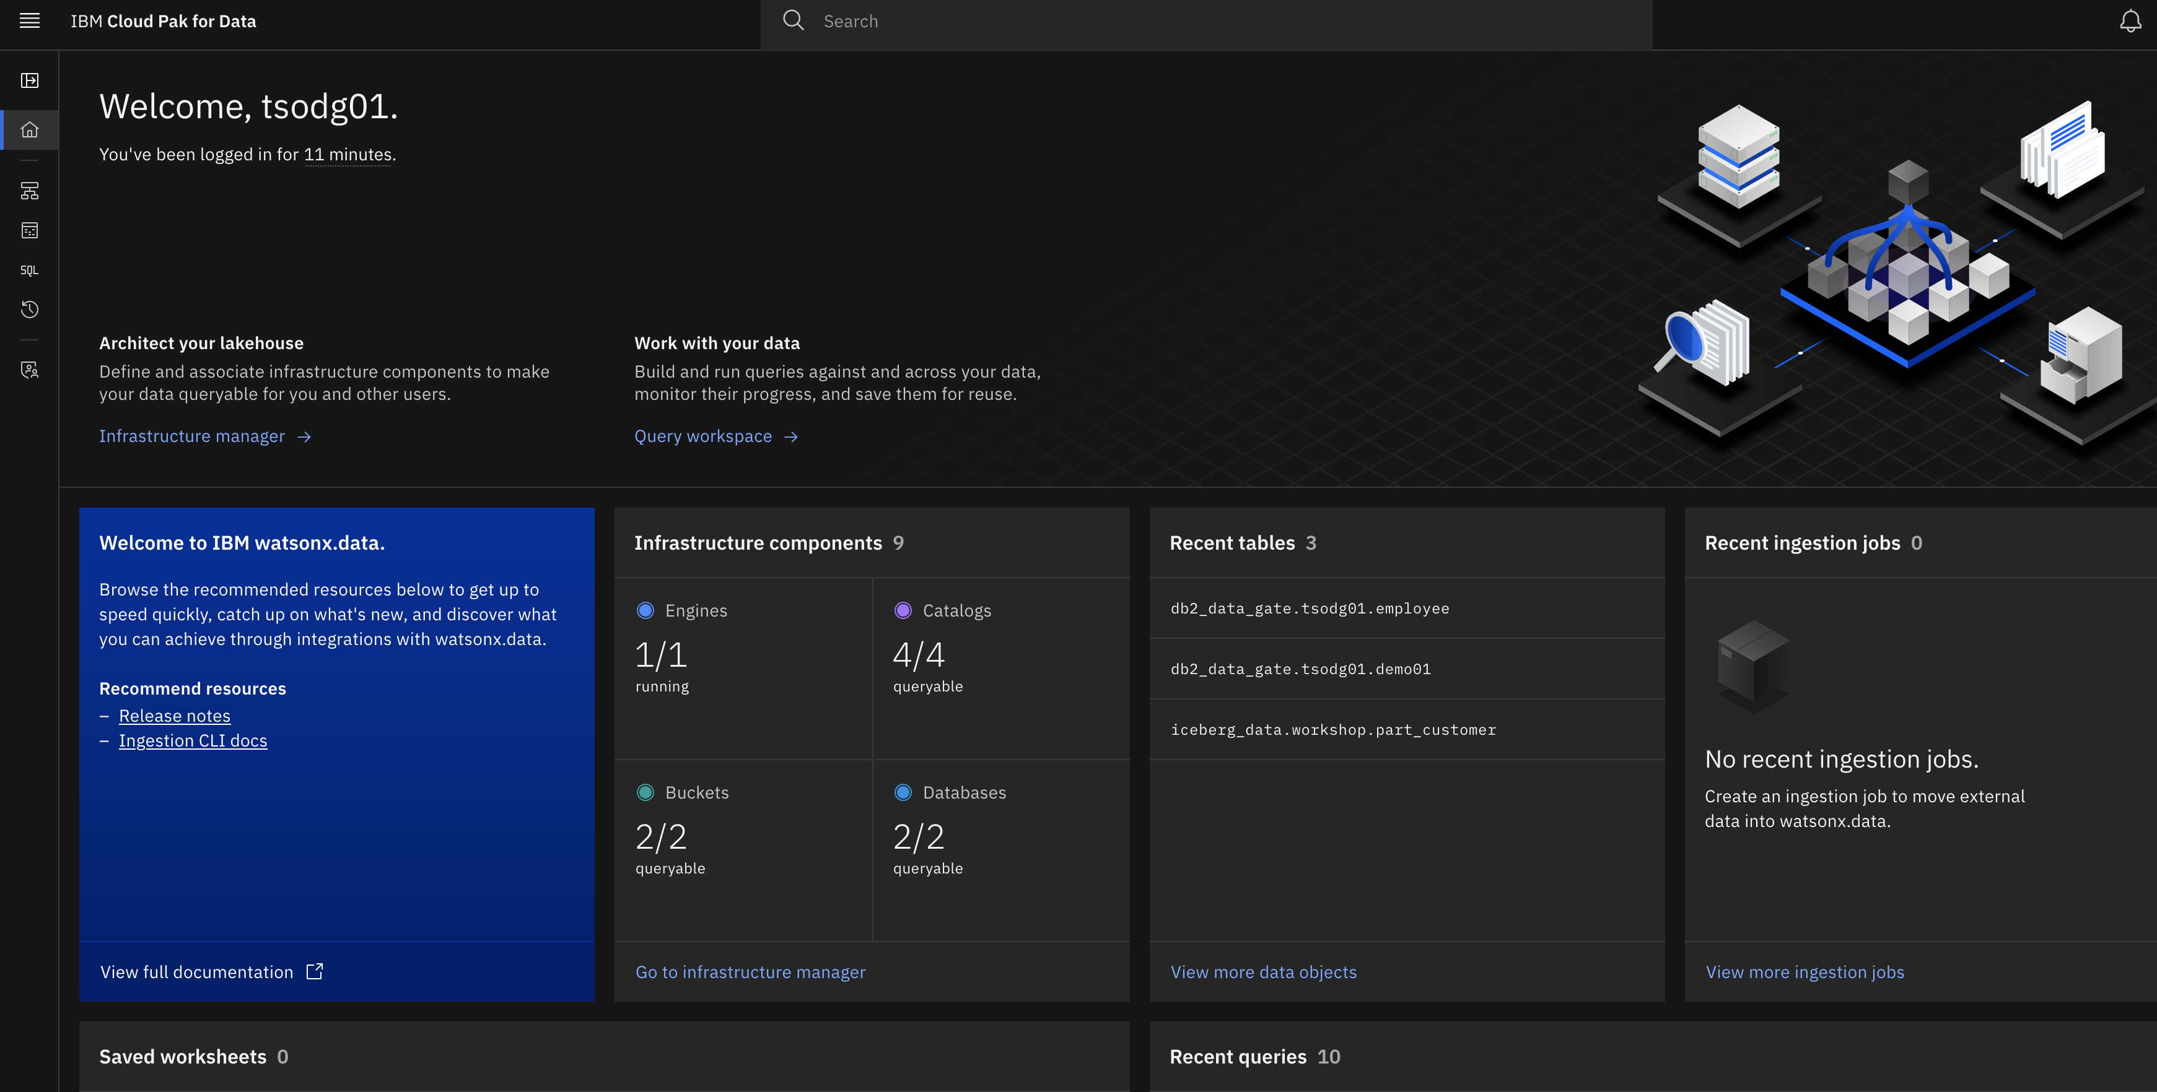

1. Expand the left hand side navigation menu by clicking on the expand navigation symbol 

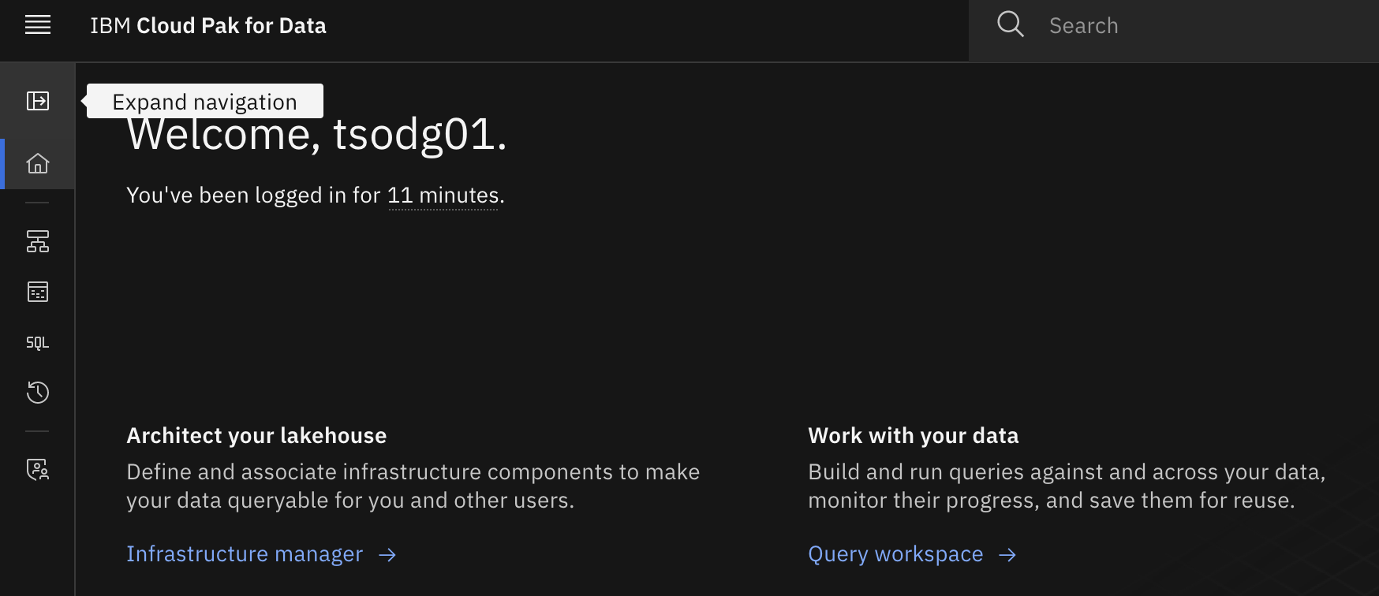

The following image describes the console pages that are available, and when you would need to navigate to them.

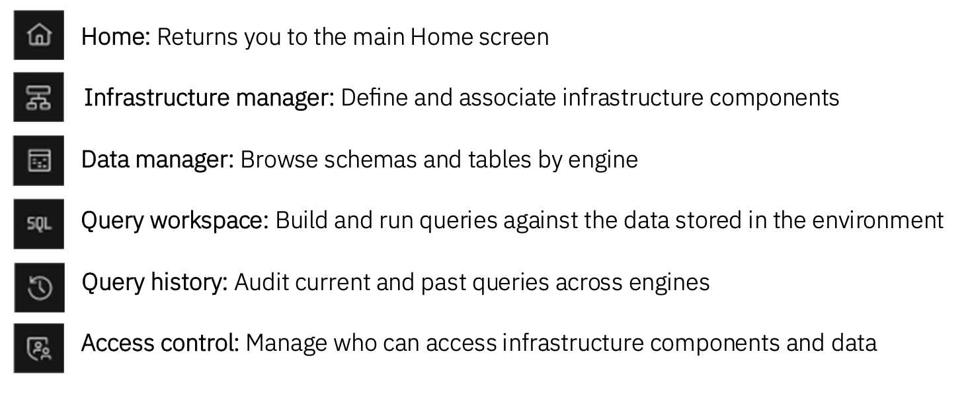

## Watsonx.data Infrastructure Manager

1. Expand the navigation menu again and click on the infrastructure manager tab to view the components that are setup on watsonx.data

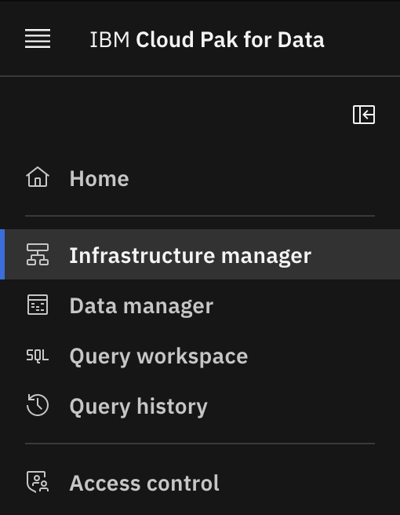

1. The Infrastructure manager page opens with a graphical canvas view of the different infrastructure components currently defined in this watsonx.data environment: Engines (blue layer), Catalogs (purple layer), Buckets (green layer), and Databases (also blue).

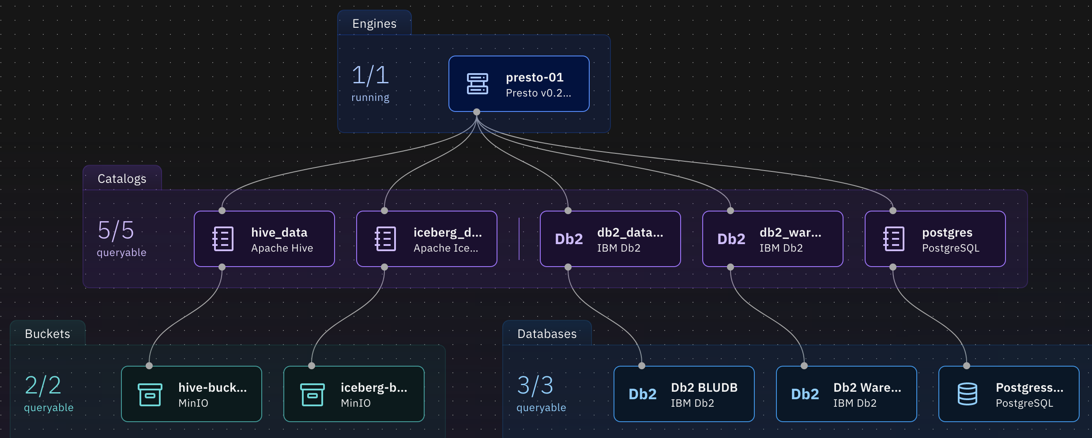

There are four infrastructure components that can be configured in watsonx.data:

* **Engines**: A query engine is used to run workloads against data in watsonx.data. Watsonx.data supports multiple engines; this lab will use Presto as the query engine.
* **Catalogs**: Metadata catalogs are used to manage table schemas and metadata for the data residing in watsonx.data or accessed through the platform. Metadata can be shared across different query engines, simplifying querying.
* **Buckets**: Watsonx.data stores data in object storage. Specifically, data is stored in buckets, which are identified storage areas within object storage, similar to file folders. AWS Simple Storage Service (S3), IBM Cloud Object Storage (COS), and MinIO object storage are supported.
* **Databases**: External databases can be registered and used in watsonx.data. Schemas and metadata for objects within a database are stored in a watsonx.data catalog.

The watsonx.data Developer Edition comes pre-configured with the following components:

* + **presto-01**: This is a Presto query engine. It is used to interact with data in the lakehouse.
  + **iceberg_data**: This is an Iceberg catalog, residing within watsonx.data’s embedded Hive Metastore (HMS). It manages tables that have been created with the Iceberg open table format. This catalog is associated with the iceberg-bucket object storage bucket.
  + **hive_data**: This is a Hive catalog, also residing within the embedded HMS. This catalog is intended for use with non-Iceberg tables, where data is stored in files (such as Parquet, ORC, or CSV), but they are not using the Iceberg table format. This catalog is associated with the hive-bucket object storage bucket.
  + **iceberg-bucket**: This is a bucket in the embedded MinIO object store. The table data stored here is associated with the iceberg_data catalog.
  + **hive-bucket**: This is a bucket in the embedded MinIO object store. The table data stored here is associated with the hive_data catalog.

You are likely asking yourself why the environment, by default, is set up with two different catalogs (Hive and Iceberg). Generally speaking, tables that you create and populate within watsonx.data should use the Iceberg open table format because they inherit beneficial capabilities like transactional consistency, schema and partition evolution, snapshots for time travel queries and rollback, and improved query efficiency. As mentioned before, Iceberg was built to handle huge datasets and analytics workloads.

However, you may need to land existing data into watsonx.data’s object storage that is in supported data file formats (like Parquet or ORC) but aren’t using the Iceberg table format. In this case, you can land your data into a Hive catalog-managed bucket and then create a non-Iceberg format table on top of it. You can then create a new Iceberg version of the table (managed by an Iceberg catalog) with the same table definition and populate it with the data from the original table. This is made easy by a common SQL statement called CREATE TABLE AS SELECT (or CTAS for short), which is supported by Presto. You will see this in action later in this lab. For large-scale conversion jobs, Spark can also be used.

The following components have been added for this lab to access and work with other existing data sources:

* + **Db2 OLTP (Data Gate Target)**: Database connection to the Db2 LUW database that is used by Data Gate as its synchronization target for Db2 for z/OS data. This database was explored in previous sections of this lab.
  + **db2_data_gate_catalog**: Metadata catalog for Db2 schema and table information.
  + **Postgres DB**: Database connection to a PostgreSQL database.
  + **postgres_catalog**: Metadata catalog for PostgreSQL database schema and table information.
  + **Db2 Warehouse**: Database connection to a Db2 Warehouse.
  + **db2_warehouse_catalog**: Metadata catalog for the Db2 Warehouse.

From the infrastructure management section you can add existing cloud object storage buckets, connections to databases, query engines, and catalogs. Though we won’t explore the access management section of watsonx.data, access control can be granted at the engine, catalog, bucket, database, and schema, table, and column level, ensuring secure and granular data access.

## Watsonx.data Data Manager

The Data manager section of watsonx.data can be used to explore and curate your data. It includes a data objects navigation pane on the left side of the page with a navigable hierarchy of engine > catalog > schema > table.

Presto (and many other database systems) organizes tables, views, and other database objects in schemas.

In Presto, tables can be identified in queries by specifying the catalog, schema, and table name (separated by periods). For example:

SELECT COUNT(*) FROM DATA_CATALOG.SALES_SCHEMA.CUSTOMER_TABLE

1. Expand the navigation menu, and select the ‘Data Manager’ tab.

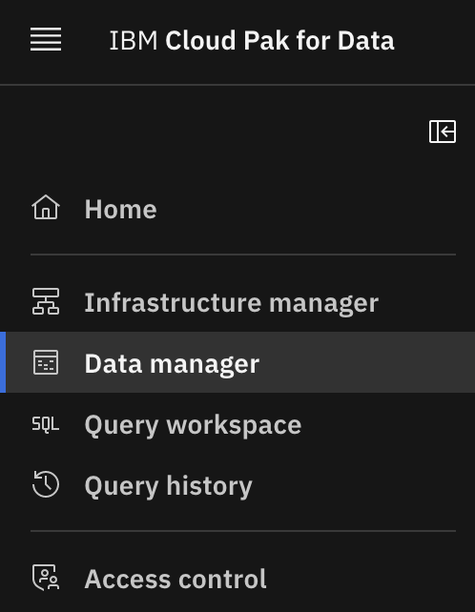

The Data manager page opens, with a navigation pane on the left-hand side that you can use to explore your data.

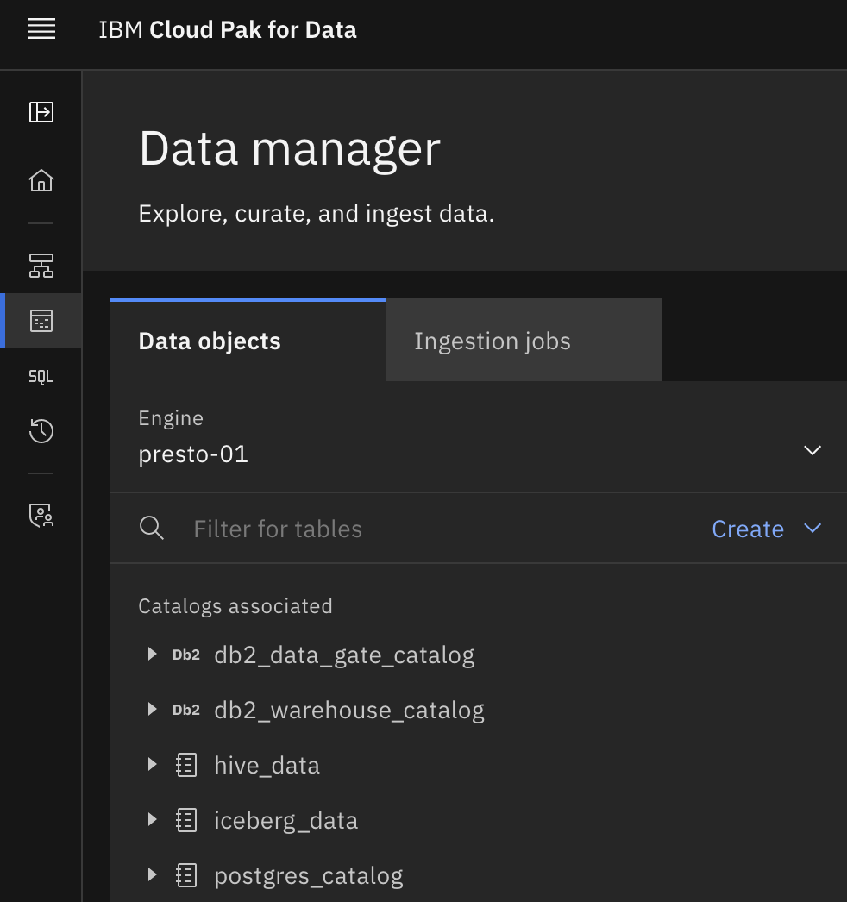

The top-level navigation point is the query engine. You start by selecting an engine that is associated with the catalog and bucket you want to manage. As there is only one engine in this environment, presto-01, it is selected by default. If this was an environment with multiple engines defined, you would have the choice of selecting any one of the engines you have set up (as the administrator) or that you’ve been given access to (as a non-administrator).

With the engine selected, you can now navigate through the catalogs associated with the selected engine (the catalogs are listed in the Catalogs associated section on the left).

Note: The web interface may automatically expand catalogs and schemas, as well as remember when catalogs and schemas were expanded previously. To simplify the screenshots in this lab, catalogs and schemas unrelated to the activity at hand are typically collapsed. So, what you see may not look exactly like what the screenshots in the lab show.

1. If the db2_data_gate_catalog section is not fully expanded, expand it to see the schemas present on the Db2 LUW database. Do this by clicking on the rightwards facing arrow to the left of the db2_data_gate_catalog section.

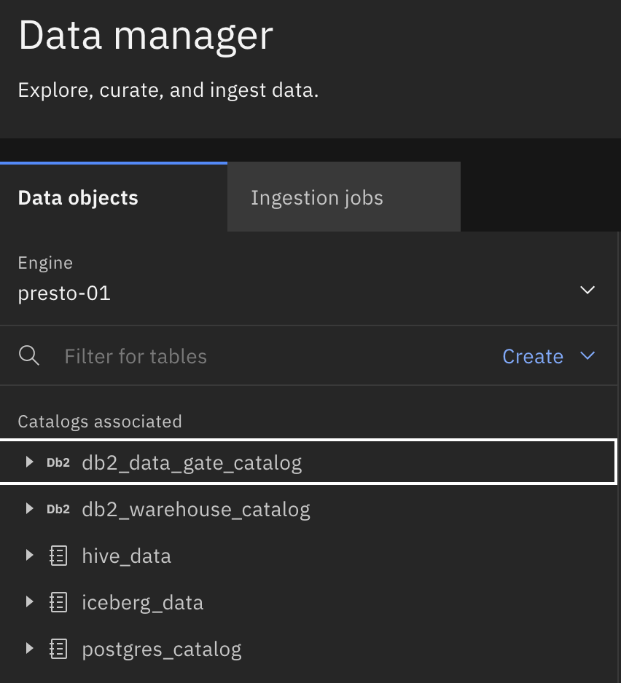

Note: If you encounter an error when expanding the db2_data_gate catalog, or no schemas appear, hover over the right-hand section of the row and click the ‘refresh’ icon to trigger a reload of the items present in the catalog:



1. Scroll down through the schemas present in this Db2 database until you see your <schema> value. Expand your <schema> by clicking on the rightward facing arrow or the <schema> row. If you have successfully completed the previous sections of the lab, you will see the 3 Db2 for z/OS tables (EMPLOYEES, DEMO<NN>, and ITEM) that you have loaded into Data Gate.

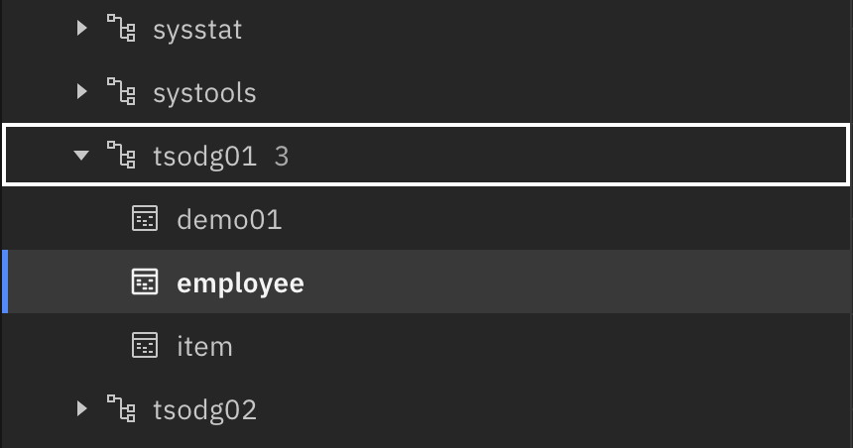

1. Select the employee table present in your <schema>. You are presented with a schema definition of the employee table.

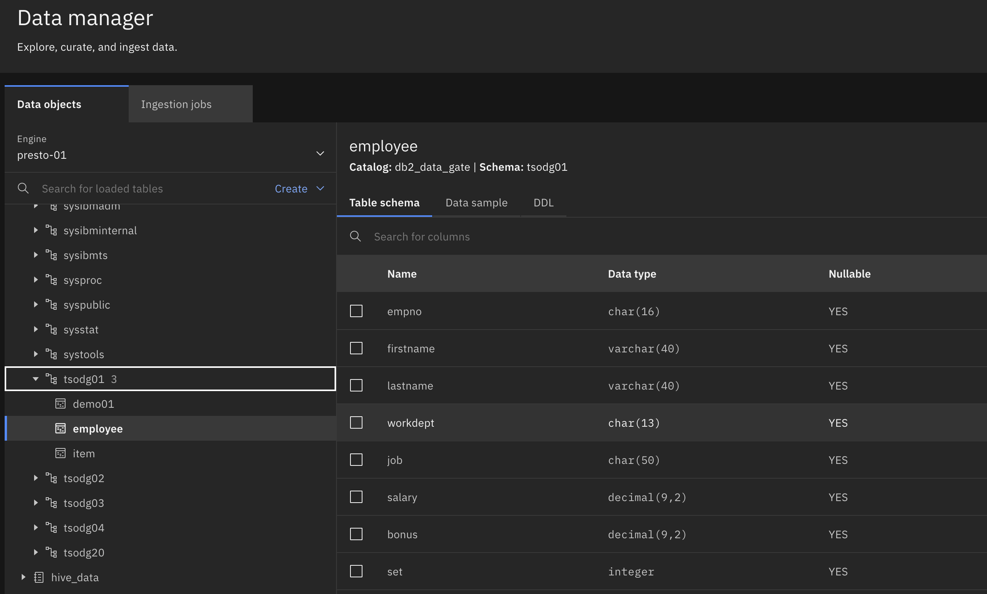

Two other tabs are available in this table view, ‘Data sample’, and ‘DDL’. The data sample section shows a preview of the data present in the table.

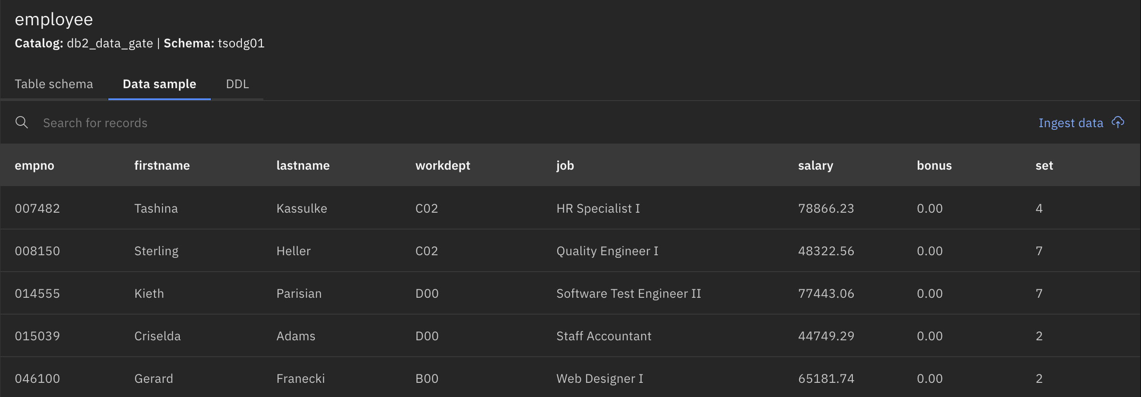

The DDL section shows the table definition Presto references within this catalog when SQL statements are executed in the engine.

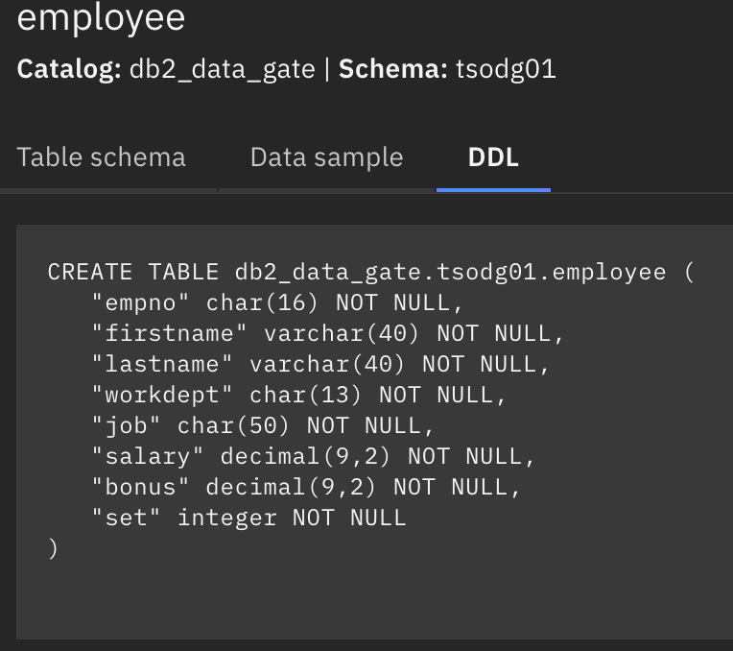

### Create a Schema in the Iceberg Catalog and Bucket

In this section, we will create a schema in the iceberg data catalog, which will be used later as a destination for offloading a table from a data warehouse.

1. From the top navigation menu, in the ‘Data objects’ section, expand the ‘Create’ drop-down menu, and select ‘Create schema’

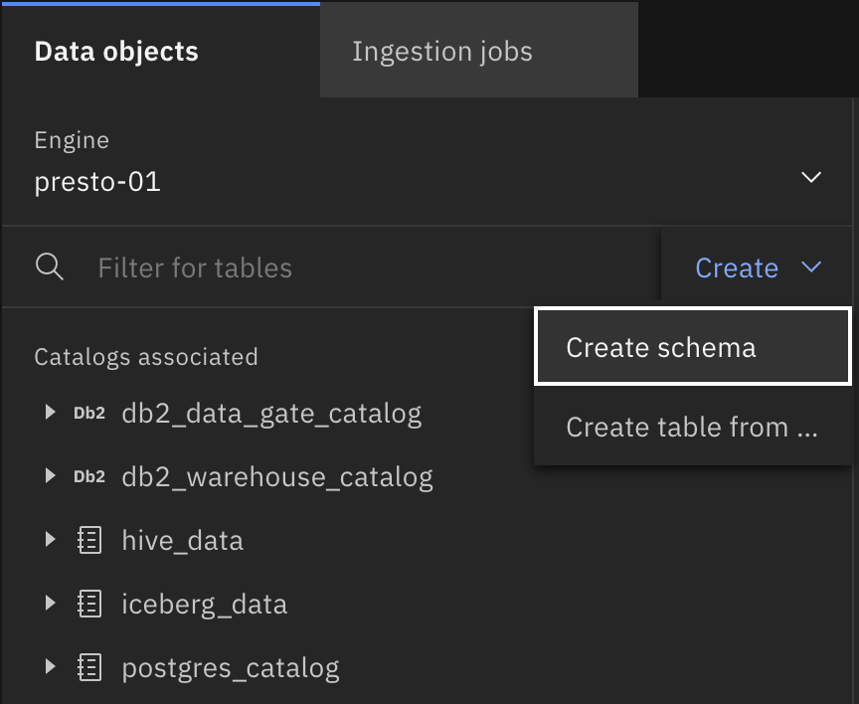

1. For the catalog, make sure ‘iceberg_data’ is selected. **IMPORTANT**: name the schema your assigned <schema> value and click create. We will use this schema later on in the lab.

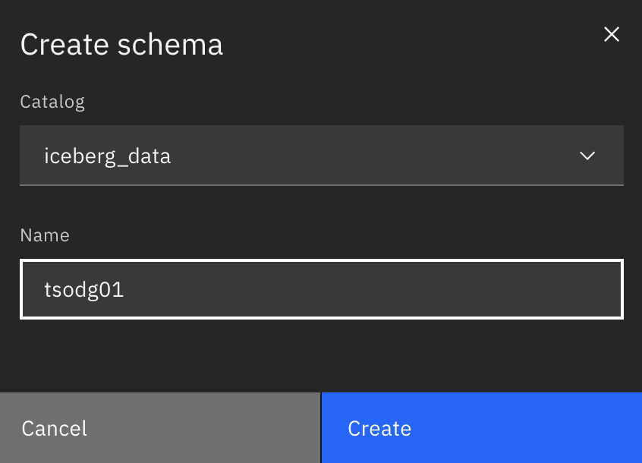

1. If you expand the ‘iceberg_data’ catalog section, you will see your newly created schema present.

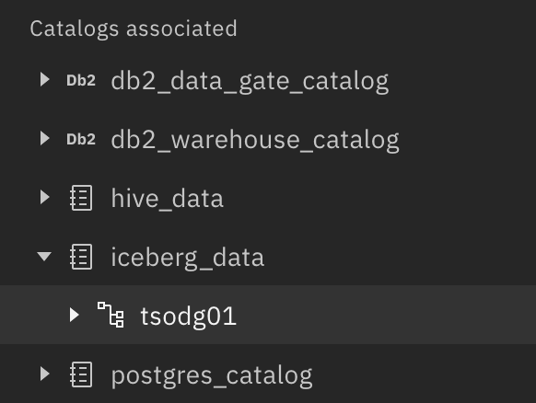

In the data manager section, you can also create a table, from a file, in Presto. Additionally, schemas and tables can be created using SQL and with Presto’s command line interface. We will not cover this functionality in this hands-on-lab.

## Watsonx.data Query Workspace

Databases and query engines such as Presto have multiple ways that users can interact with the data. For example, there is usually an interactive command line interface (CLI) that lets users run SQL statements from a command terminal. Also, remote applications can use JDBC (Java Database Connectivity) to connect to the data store and run SQL statements.

The watsonx.data user interface includes an SQL interface for building and running SQL statements. This is called the Query workspace. Users can write or copy in their own SQL statements, or they can use templates to assist in building new SQL statements.

In addition to one-time execution of SQL statements, SQL statements that need to be run repeatedly can be saved to a worksheet and be run as often as needed later.

1. Expand the left-hand navigation menu and select the ‘Query Workspace’ tab. Alternatively, click on the 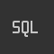 icon directly from the left-hand navigation menu.

The Query workspace page opens with a data objects navigation pane on the left side and a SQL editor (workspace) pane on the right side.

Like in the Data manager page, the top of the navigation pane directs you to select an engine to use. It is this engine that will be used to run the SQL statements entered here.

The only engine that exists in this lab environment is the presto-01 Presto engine, which is selected by default.

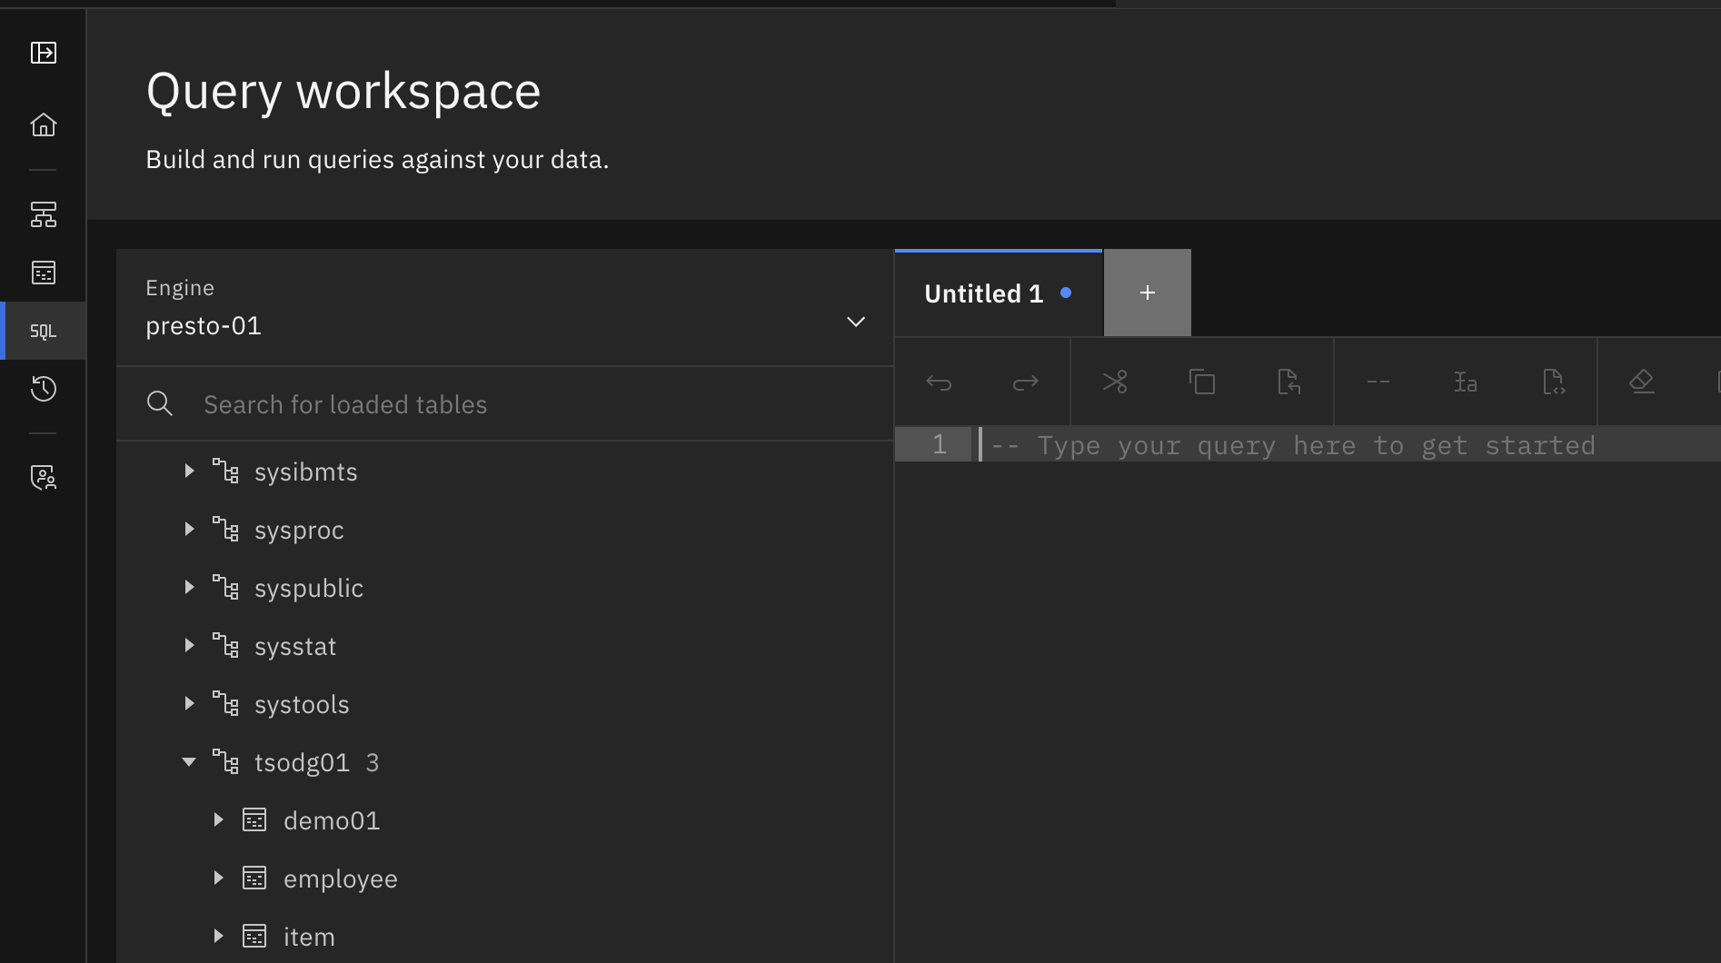

### Federated Queries

Unlike traditional database systems, Presto doesn’t have its own native database storage. Instead, Presto supports separation of compute and storage, with dozens of connectors that let Presto access data where it lives – which could be in relational databases, NoSQL databases, data warehouses, data lakes, data lakehouses, and more.

With Presto’s *federated query* capability (frequently referred to as *data federation*, or simply *federation*), enterprises can combine data from their existing, diverse sources with new data that they have in watsonx.data, rapidly unlocking insights without the complexity and cost of duplicating or moving data.

In other words, you don’t need to move data to query it with Presto. This is extremely valuable when it comes to cost, time, and resources. Instead of moving data or using the extract-transform-load (ETL) process to integrate your data in one place to query it, Presto can provide unified access to—and federate queries across—all of your data sources.

In this section you will combine data from watsonx.data’s object storage with data in Db2 and PostgreSQL databases. You will also observe how Data Gate allows for near real-time synchronized Db2 for z/OS data to be accessed in watsonx.data.

1. Find your <schema> from the db2_data_gate_catalog and expand the section. If you hover over the right-hand side of the row with your employee table, the following query template icon will appear . Once you click on the query template icon, you are shown several templates which can be used to populate the query editor. Click on the ‘Generate path’ option to help you create the query for the next step.

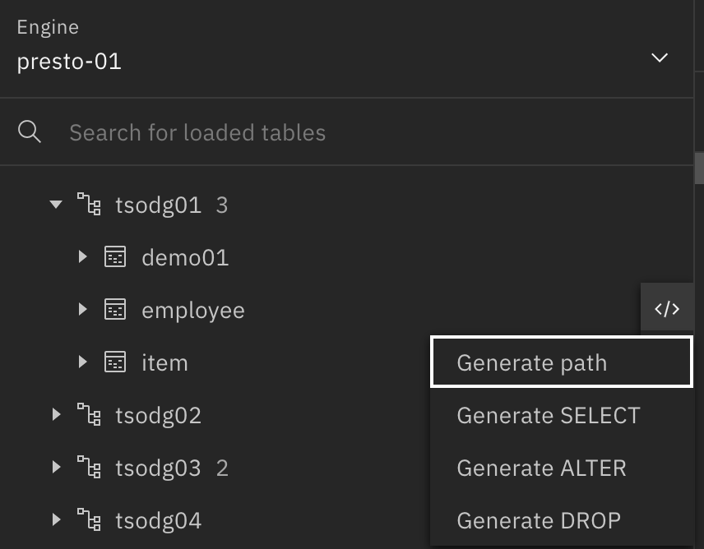

1. Type in the following query into the SQL editor, replacing the <schema> value with the value in your lab worksheet. Next, click the ‘Run on presto-01’ blue button to execute the query using the Presto query engine.

SELECT COUNT(*) FROM DB2_DATA_GATE_CATALOG.<SCHEMA>.EMPLOYEE

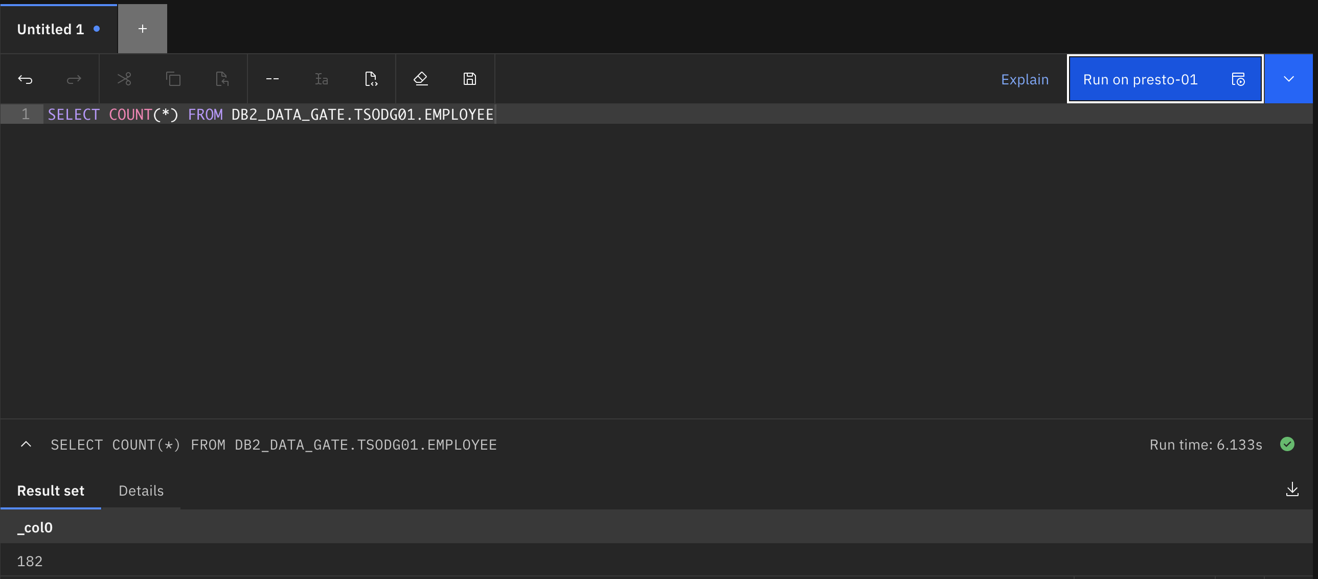

You will see the result set returned at the bottom section of the query editor.

1. Now, navigate back to your Data Gate demo application at <dg_demo_url>. The monitoring section of the demo app displays the current number of records present in the tables, this number should correspond to count returned by the query you executed in the previous step. Simulate more activity on the Db2 for z/OS table by clicking the ‘GENERATE WORKLOAD’ button. If you already inserted the maximum number of records, instead, press the ‘CLEANUP’ button.

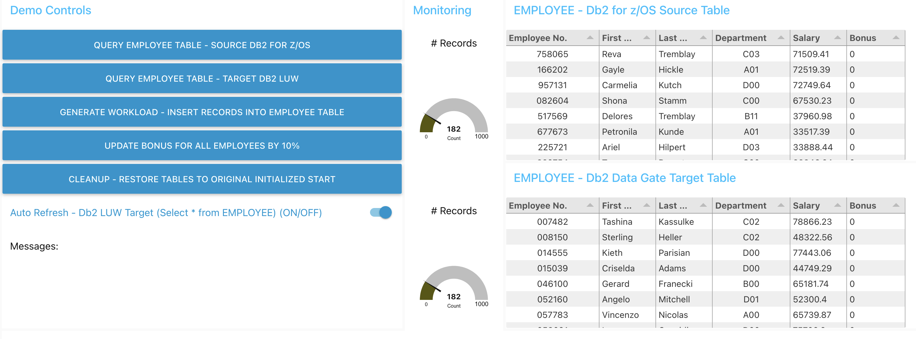

1. Navigate back to the watsonx.data user interface, and rerun the same query you just ran.

SELECT COUNT(*) FROM DB2_DATA_GATE_CATALOG.<SCHEMA>.EMPLOYEE

You now should receive a different count, corresponding to the number of records displayed by the demo application.

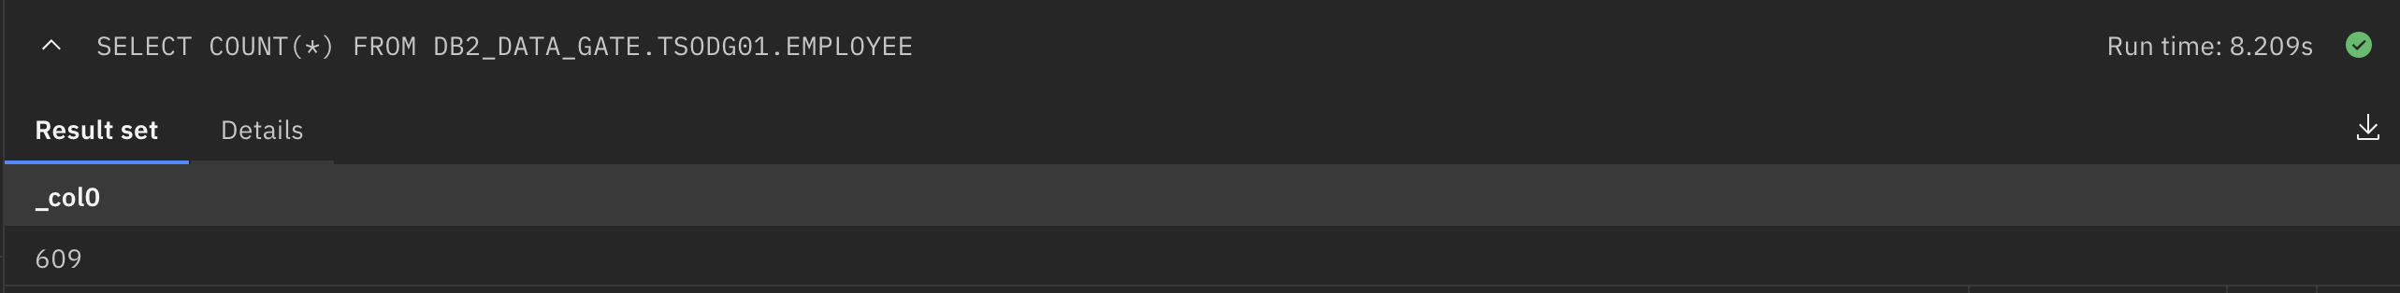

With Data Gate, you can guarantee that your analytics and AI initiatives always have access to the most recent Db2 for z/OS data.

From the SQL editor, you can also examine a query’s execution plan. Presto includes an explainfacility that shows how Presto breaks up and distributes tasks needed to run a query. A graphical representation of a query’s execution plan – what’s commonly referred to as visual explain– is available from within the Query workspace. If interested, click on the ‘Explain’ button on the right-hand side of the query editor to view the execution plan.

You can also save queries for future use by clicking the save icon in the top menu bar.

### Federated Join

Typically, for most analytical, AI, or business reporting initiatives, data is needed from across different sources. With watsonx.data it is easy to access data across your enterprise. We will demonstrate how you can use watsonx.data’s SQL editor to combine data from a nationality table in Postgres, and an employee table from Db2 for z/OS synchronized by Data Gate.

1. The query is provided in the saved worksheets section of the query editor, in the bottom left-hand corner of the screen. Select the worksheet titled Postgres_Db2Z_Join.

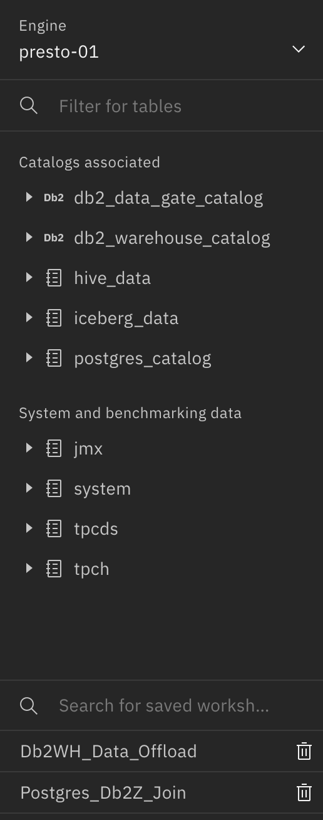

The query editor will be populated with the contents of the saved query. **IMPORTANT**: make sure to change the <schema> to your assigned <schema> value.

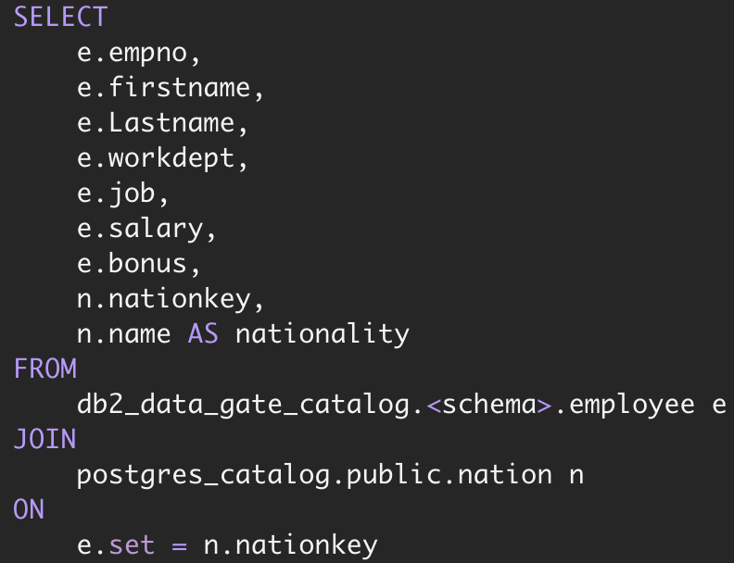

1. Run the query by clicking the ‘Run on presto-01’ button.

In the result set, you will see how the table now shows the nationality of the employees:

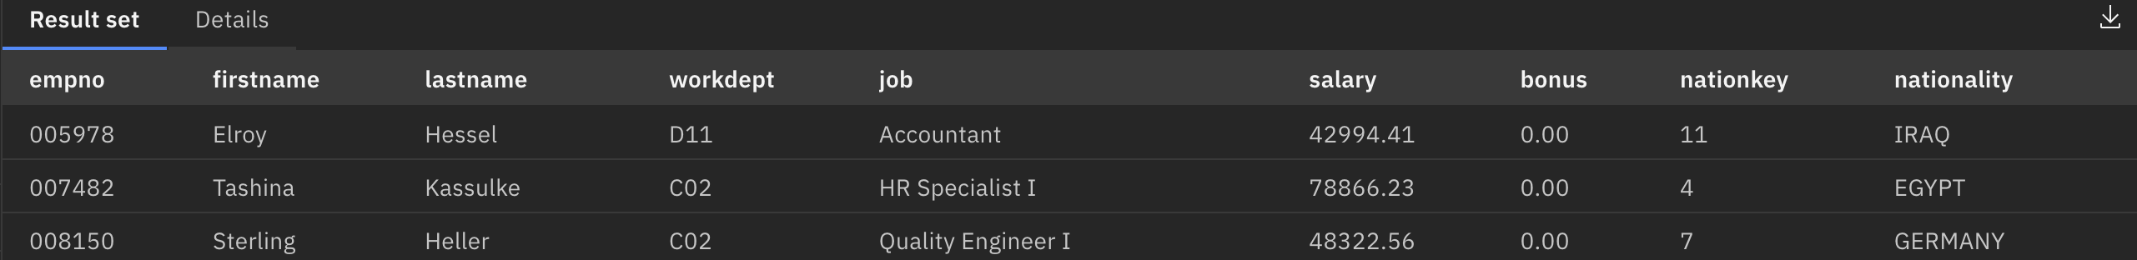

To work with this result, you can download this result set, or create a new table from it, using a ‘create table as select’ statement in Iceberg, Hive, or other connected databases.

## Offloading Data from a Data Warehouse

Many companies maintain expensive data warehouses, whether on-prem or cloud-based for mission-critical workloads. These high-performance and low-latency data warehouses are often worth the high cost because of the timely insights generated. However, there is often data in these data warehouses that is not needed, due to infrequent access, or less stringent application demands. In these cases, it can make financial sense to offload ‘unneeded’ data to a lower-cost solution to prevent the periodic scaling of data warehouses and costs. For example, a retailer may not need sales data from a longer time period in their data warehouse but would want to keep more recent data to analyze new trends.

With watsonx.data, data that doesn’t really need to be in a data warehouse can be offloaded to lower-cost object storage. Applications that need to access this data can query it through the Presto or Spark query engines. In this section, we will demonstrate ‘moving’ data from a Db2 warehouse into watsonx.data.

1. We will run a query to load ‘stale’ sales data from a Db2 Warehouse into watsonx.data’s Iceberg storage. This query is provided in the saved worksheets section of the query editor, in the bottom left-hand corner of the screen. Select the worksheet titled Db2WH_Data_Offload.

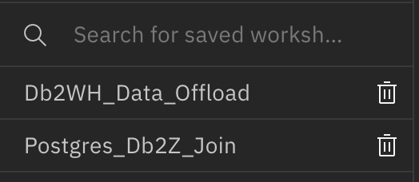

1. The following query will be populated in the query editor. Make sure to replace the <schema> text with the <schema> value on your worksheet.

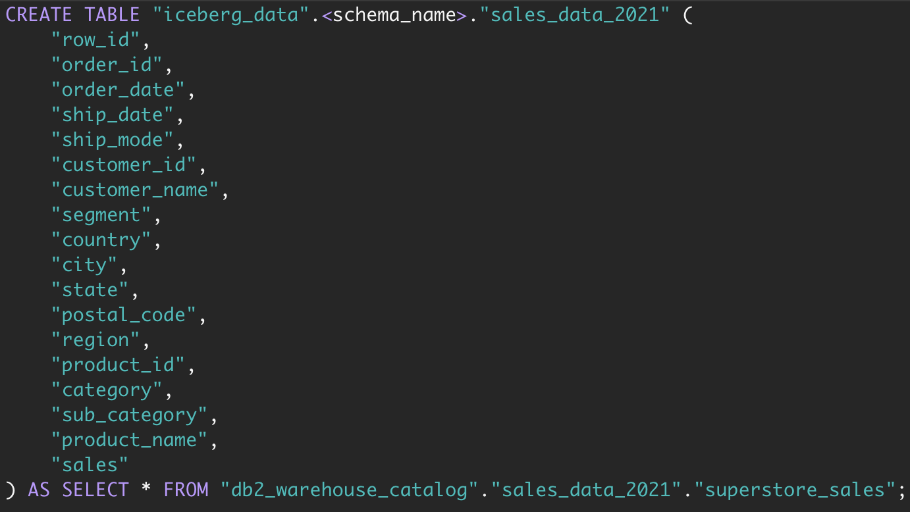

1. Run the query by clicking the ‘Run on presto-01’ button. In the result set you will see the number of rows that have been inserted into the Iceberg table.

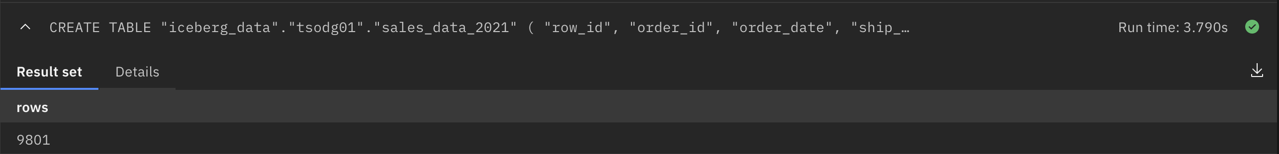

1. From the left-hand catalog navigation pane, find the iceberg_data catalog, and expand it. Find the <schema> that you created earlier, and you should see the newly created sales_data_2021 table. If you don’t see the table, click the refresh button on the schema row.

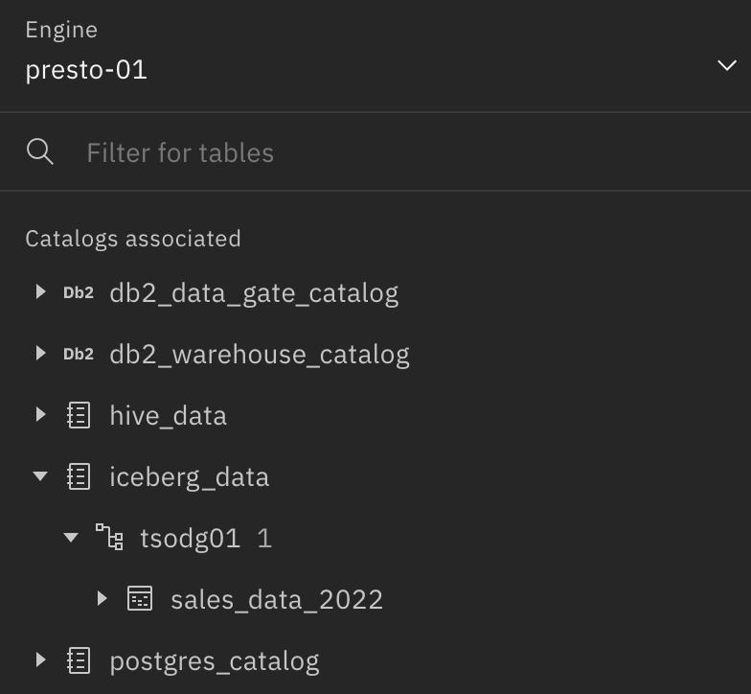

At this point, you could then delete the table from the data warehouse and free up storage space and reduce costs. Now that the data is stored in an Iceberg table, features such as schema evolution, data snapshots, time travel and rollback, and data compaction can be used through a query engine. Additionally, the data will be automatically partitioned more efficiently, leading to faster and less expensive queries.

Note that there are other ways to load data into watsonx.data, including:

* + Uploading from a file.
  + Creating an ingestion job from the UI to read data from an object storage bucket. This can be done using the ibm-lh CLI as well.
  + From the infrastructure manager, registering an existing object storage bucket in watsonx.data and creating a table using SQL.

End of section

# Summary

Concluding this lab, you have learned the capabilities of IBM Db2 for z/OS Data Gate. By automatically synchronizing z/OS Db2 data with low latency into the IBM Cloud Pak for Data environment, Data Gate opens the possibilities for using your existing z/OS Db2 data to provide new business value for your company in a cost-effective manner.

You have also seen how Data Gate and watsonx.data can be integrated with each other to enable access to Db2 for z/OS data in watsonx.data. Watsonx.data makes it possible for enterprises to scale analytics and AI with a fit-for-purpose data store, built on an open lakehouse architecture, supported by querying, governance and open data formats to access and share data. With watsonx.data, you can connect to data in minutes, quickly get trusted insights and reduce your data warehouse costs.

More information on IBM Db2 for z/OS Data Gate can be found at <https://www.ibm.com/products/db2-for-zos-data-gate>

[https://www.ibm.com/support/producthub/icpdata/docs/content/SSQNUZ_latest/svcwelcome/dg.html](https://www.ibm.com/support/producthub/icpdata/docs/content/SSQNUZ_latest/svc-welcome/dg.html)

More information on watsonx.data can be found here:

<https://www.ibm.com/products/watsonx-data>

Please send questions and comments to:

John Goodyear (johngood@us.ibm.com)

Artem Minin (aaminin@ibm.com)